https://docs.google.com/document/d/1f3E77M2ahXWe47Bchv1tI2buhk_yU2z6/edit?usp=sharing&ouid=101670233461923423744&rtpof=true&sd=true
Attachment E. Community Engagement and Collaborative Governance Plan 15 Points 10 p
Youthprise/Sabathani Community Center/Minneapolis Green Career Pathways Collaborative
- Past Community Outreach and Engagement Conducted: (4 points) 2 pages
Overview: Our Green Careers Pathways Collaborative EPA Application is a combined effort of 20 community-based workforce development CBOs with deep connections in our communities.
Like a healthy Oak, the strategies, projects and implementation approach we included in this application have grown from deep community roots, recent branches and new leaves.
Deep Community Roots: Summit Academy OIC (SAOIC) founded in 1964, Sabathani Community Center (SCC) founded in 1966, Minneapolis American Indian Center (MAIC) founded in 1975, and Center for Energy and Environment (CEE) founded in 1979 have listened to Northside, Phillips and Southside residents and connected them with food shelves, job counseling/training and home weatherization services to build household and community wealth for five decades.
From these deep roots SAOIC, SCC, MAIC and CEE and newer green workforce development partners including Youthprise (YP), Resilient Cities and Communities (RCC), Minneapolis Climate Action/Regional Apprentice Training Center (MCA/RATC) were ready to put new federal IIJA funds and IRA tax credits to work in our neighborhoods and co-convened 20 experienced workforce development CBOS, city, county and business partners to co-develop our
primary strategy (CA8) and focus (Project 1) to invest 15MM in well-coordinated workforce development in our neighborhoods to remove employment barriers and expand proven, job-specific training to launch 1,000 current and future family bread- winners in rewarding careers in six high-demand skilled trades needed to cut GHGs and improve air quality.
Recent Branches: Our Minneapolis community and the whole world were rocked by an MPD officer’s murder of George Floyd in May 2020. Many in our community rose up to protest to end the MPD’s use of violent/lethal tactics. Unfortunately, in June of 2020 we lost many beloved Southside, Phillips and Northside businesses to looting/arson (including grocery stores.) Like a Phoenix rising, this challenge strengthened our city with an outpouring of neighborhood, block club & faith community volunteers distributing food to neighbors & cleaning things up. Riding this wave, the Sabathani Community Center, Minneapolis American Indian Center and Northside Institutions all decided to become Community Resilience Hubs to be all-weather resource centers for neighbors during times of need (even power outages.)
Our implementation approach will strengthen connections between block/neighborhood leaders 3 resilience hubs to help 1,000+ area households benefit from federal investments.
- We’ll connect 1k project area job seekers with job training and sign up 1.2k households for Healthy Home Energy Retrofits through the Southside (Sabathani), Phillips (MAIC), Northside Nutrition Center (MCA/NNC) resilience hubs teaming up with block clubs and neighborhood groups who mobilized neighbors for mutual aid during the 2020 uprising.
- We’ll co-launch the City’s 4th Community Resilience Hub to serve the Camden area neighborhoods in North Minneapolis through Project 4: Youthprise Village Energy & Resilience Improvements ($5MM/EPA) to transform a 3.74 -acre parcel with multiple structures at 5140 Fremont Ave N to be a net zero, multi-purpose resilience hub with affordable housing. The Sabathani, MAIC and MCA/NNC resilience hubs are currently installing solar, battery storage and geothermal and will share tips with Youthprise.
New Leaves: SCC, MAIC, SAOIC, CEE, RCC, MCA/RATC and Minneapolis Workforce Development Board (MWDB) and Hennepin/Carver Workforce Development Board (HCWDB) staff co-launched our Green Careers Pathways Collaborative (GCPC) with 20 experienced CBO workforce development partners during four work sessions between 1/31/24 and 9/24/24.
We decided to co-launch the GCPC because we saw a big challenge/opportunity as the City was preparing to boost residential energy retrofits without the needed workforce to get them done.
Based on 2 years of work by the Northside and Southside resident Green Zone Councils in 2021 8 city/community listening sessions and the work of a Community Steering Group and working groups in 2022 and 2023 the Minneapolis City Council adopted an ambitious 10-year Climate Equity Plan (CEP) approved $15 million/year in new city funding to implement the CEP. Our CBOs were excited to see key Green Zone priorities included the City’s CEP 2025 activities, but we wondered how our CBOs could grow our capacities to help the city get them done.
CEP Healthy Homes/Energy Goals and Strategies
- Ensure all 1–4-unit homes and apartments are adequately insulated and weatherized by 2040 starting with Green Zones.
- Eliminate the number of households with a housing energy burden over 6% by 2030.
- Begin transition to all electric homes.
HEH.1.3 Pilot: (2025): Begin whole home weatherization and electrification retrofit pilot to understand sequencing, build knowledge, develop work force, and further coordination with other metro cities’ initiatives using $1.4 million in ARPA/EECDBG federal funding.
CEP Economy & Workforce Goals and Strategies
- Prepare multiple Green Career Pathways for Minneapolis Residents.
- Support new green businesses and expansion of existing Minneapolis businesses.
Phase I Work Plans for Next 12 Months:
- ECW.1.3 Program: Expand workforce training for solar energy and energy efficiency.
- ECW.3.2. Program: Provide education and technical assistance for new businesses.
CEP Economy & Workforce GOALS: and Five-Year Work Plan (Our GCPC Project 1)
- Prepare multiple Green Career Pathways for Minneapolis Residents.
- Support new green businesses and expansion of existing Minneapolis businesses.
Strategy ECW.1: Prepare Green Career ladders for Minneapolis Residents. Lead(s): SHHE, CPED, & community-based worker training organizations. ACTIONS:
- ECW.1.1. Program: Educate and train 1,000 residents in green careers by 2030.
- ECW.1.3. Program: Expand workforce training for solar energy/energy efficiency.
- ECW.1.5. Process: Work with local schools, trade associations, labor unions and educational institutions to coordinate green career education and recruitment.
Two studies showed us the shortage of 1,000+ skilled workers to implement home retrofits:
CEE’s Roadmap to decarbonize all 1–4-unit homes in Minneapolis (Feb 16, 2023)
“Workforce development needs to ramp up very quickly. Thousands of projects need to be completed each year to keep the City on track to meet its goals. A workforce of nearly 1000 electricians, insulation contractors, mechanical contractors, and other trades are needed to complete the heavy volume of work required. This workforce does not currently exist.
In fact, the region is currently facing a general shortage of contractors. Workforce development in critical trade areas will be vital.“
“Advancing equity and cutting carbon can work together. Investments in underserved areas to fully fund electrification projects can save residents money on energy bills while increasing quality of life. This investment is also effective as a targeted decarbonization strategy, as areas like the Southside Green Zone have some of the oldest and least weatherized buildings in the city. Additionally, workforce development can be focused on marginalized communities to advance the equitable economic benefits of decarbonization.”
The Green Jobs Demand Analysis developed for the city by Real Time Talent, May 2024, based on interviews with employers confirmed even higher 3-year workforce gaps for Energy Auditors, Weatherization Technicians HVAC Technicians, and Solar Installers.
Launching our Green Careers Pathways Collaborative
- Green Careers Pathways Convening (1/31/24) Minneapolis Employment and Training (MET) convened staff from 20 community workforce development CBOs to brainstorm barriers and solutions green job recruitment, training, certification and placement and retention to fill 1,000+ job openings for skilled workers in six energy/buildings trades.
- Green Zone Summit Collaborative Federal Grants Workshop (2/17/24) Green Zone volunteers, RCC and SCC brought together 65 community leaders from 20 community groups 20 staff from CBOs and 25 staff from city/county departments to brainstorm ways we could co-apply for federal funding for projects to co-implement our Climate Equity Plan (CEP). In our Economy/Workforce breakout residents, CBOs, City and County staff decided to co-apply for an EPA Community Change Grant, Track I (Strategy 8) to launch our Green Careers Pathways Collaborative (GCPC) to support Green Zone residents to get hired & local businesses to access contracting.
- GCPC Workplan Development (March - June 2024) YP, SCC and RCC met individually with the 20 workforce development CBOs who each proposed specific ways they will deepen and/or expand programs over 3 years with EPA support to address barriers and implement solutions we identified on 1/31/24 to fill priority skilled workforce gaps.
- Green Careers Pathways Convening (9/24/24) MCA and the City re-convened our 20-workforce development and business partners at the RATC to confirm our work plan.
Youthprise Village Partner Conversations - Through our 3-year Opportunity Reboot project and EPA-funded Northside Safety Net project Youthprise met with youth, youth-serving CBOs and community leaders to find ways we can expand economic opportunities and green career pathways for youth/young adults. We’ve also meet with Camden area neighbors and future tenant partners to include their input as we develop our plans.
1.3. B. Community Engagement Plan Implementation: (6 points)
Overview: Successfully implementing our 4 projects to achieve our 3-year goals depends on GCPC’s Leadership Team successfully engaging and coordinating the work of our 4 priority stakeholder groups – (1) Neighborhood Leaders (2) the staff of 20 collaborating CBO (3) Local Government partners, (4) and Business/Employer/Contractor partners.
Our Community Engagement Methods 🡪 Mitigating Barriers 🡪 Involving Key Stakeholders
Our GCPC Leadership Team including our Grant Manager (YP:1fte), Project Manager (SCC:1fte) and Partnership Manager (RCC:1fte) will draw forth the creativity/capabilities of 20 CBOs & 30 neighborhood, government and business partners during 4 regular gatherings:
ONE – Resilience Hub Community Council Meetings (quarterly) at the 3 Resilience hubs to support/coordinate the outreach of 4 neighborhood associations, 32 block connectors (4 x 8) & 4 home energy navigators meeting to plan spring, summer & fall door knocking & events to
- Connect with and refer 150 youth/adults per year in their hub zone to local CBOs offering 1 on 1/small group support to job seekers to progress through green career exploration
- Sign up 200 households/year in their hub zone for home energy audits, with follow up.
Community Engagement Methods 🡪 Mitigating Barriers 🡪 Engaging Residents
- Well facilitated quarterly outreach planning meetings hosted by the 3 resilience hubs
- Coordinated calendar of door knocking and outreach events, CBO open houses, etc.
- On-line (& hard copy binder) Climate Equity Plan Resource Guides – listing upcoming job training cohorts, explaining the steps to sign up for a home energy audit, etc.
- Easy to use Community Engagement CRM Platform/phone app/laptops the 3 Hub Coordinators, 12 neighborhoods, 96 block connectors, 12 energy navigators will use to sign up youth and adults for job training and households for home energy audits.
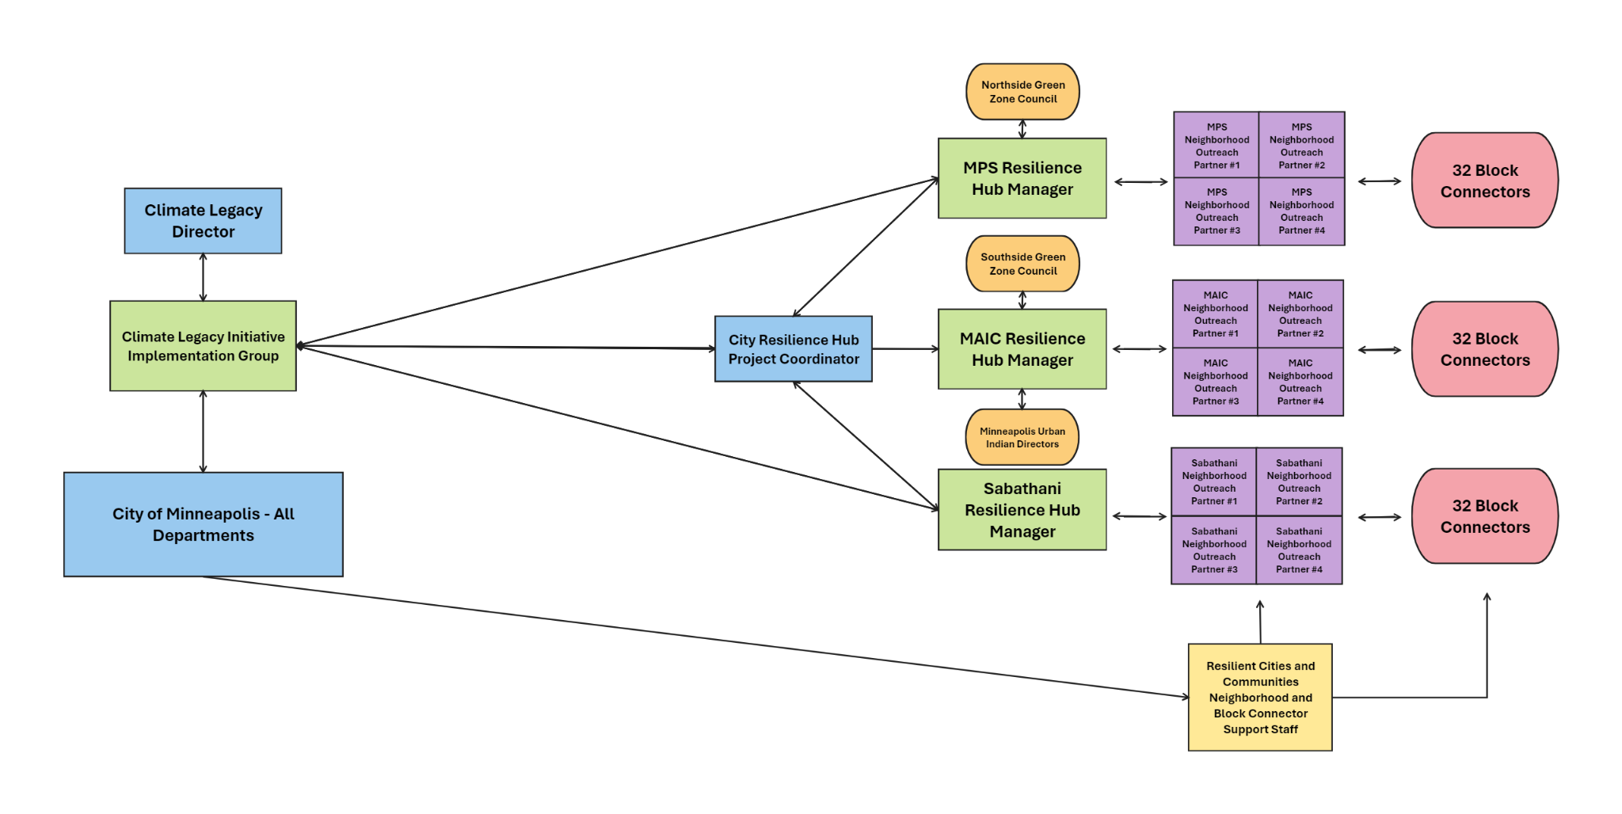TWO - Our Green Careers Pathways Coordinating Council Meetings will bring together 20 CBO partners, and neighborhood, business, trades and government reps. During quarterly meetings
- CBOs and Work Teams will share updates on their outreach, job training and employer recruitment activities/outcomes/successes/challenges and number of graduates hired.
- Our big tent of partners will brainstorm solutions to challenges shared by Teams/CBOs.
- Community, CBO government, business, union and worker reps will step up and ask colleagues in their networks (community, business, trades, unions, government) to provide the resources (bottom up &/or top down) that each Team/CBO has requested to keep them on track to achieving their annual targets to achieve 3-year overall goals.
Community Engagement Methods 🡪 Mitigating Barriers 🡪 Enabling Career Pathways
- GCPC’s Multi-Stakeholder Partnership – all key voices/resources at the table. Partners maintaining mutual transparency/accountability to meet our 3-year goals together.
- Well-facilitated Coordinating Council meetings co-led by GCPC managers/city/county
- Shared Community Engagement CRM Platform/phone app that partners will use to
- Follow job seeker progress 🡪 block referrals 🡪 green career exploration 🡪 training referrals 🡪 CBOs will use Workforce 1 Platform/App to follow/support participants to complete 🡪 job training 🡪 internships 🡪 Certification 🡪 hiring 🡪 retention.
- Follow individual households/homes requesting energy audits through 🡪 audit completion/recommended scope of work 🡪 financing package offered 🡪 owner approval 🡪 pre-weatherization 🡪 health retrofits 🡪 air sealing/insulation 🡪 electrification/ASHP/HVAC 🡪 inspection 🡪 resident energy/health education.
THREE – Six GCPC Work Teams (1) Outreach, (2) Mentoring, (3) Training, (4) Business, (5) Startups (6) Finance. CBO’s implementing similar scopes of work will meet monthly for peer-learning and problem solving and will invite neighborhood, local government, business, worker and union partners to join their monthly calls when appropriate. Monthly Team calls will be facilitated by Work Team co-leads with support from the GCPC Program Manager and/or Partnership Manager to support implementation of CBO work plans, develop team-wide resources & track/report Team outputs/outcomes quarterly to meet annual/3-year benchmarks
Community Engagement Methods 🡪 Mitigating Barriers 🡪 Engaging CBOs + Key Partners:
- Peer Learning, mutual accountability, problem-solving among CBOS doing similar work
- Shared Strategy Engagement Platform (i.e. Insight Vision) Team members will track/ manage/support CBO and partner next steps toward achieving 1 & 3-year team goals.
- Outreach Team: Engagement Methods 🡪 Mitigating Barriers: (1) Resilience Hub Outreach Coordination Meetings – RCC, SCC, Resilience Hub and neighborhood staff will meet quarterly with block connectors and home energy navigators to plan & coordinate, (2) Block Club Outreach and (3) Neighborhood Outreach Events to connect 1 on 1 with neighbors to sign up 400 youth/adults/year for career exploration and 500 homes/year for energy audits.
Outreach Team CBOs/Partners: RCC, SCC, Bharat Balyan, Resilience Hub Coordinator, Minneapolis Health, Resilience Hub Coordinators at Sabathani, MAIC, and MPS Nutrition Center/MCA, neighborhood staff, block connectors and Home Energy Navigators.
- Mentoring Team: (coordinated by SCC) Engagement Methods 🡪 Mitigating Barriers: 13 experienced CBOs will support youth and adults to overcome employment barriers through (1) Individual support/coaching, (2) Group Career Exploration/Empowerment (3) Online career self-assessment, and (4) Referrals and follow to complete job training/certification.
Youth Mentoring CBOs/youth they serve: Migizi Native American, COPAL southside Latinx, Sabathani Community Center (SCC) southside Black, Latinx, Pillsbury United Communities (PUC) Phillips/Northside, Northside Safety Net (NSN) northside, Summit Academy (SAOIC) green construction classroom recruitment, Beacons (YMCA) Camden Native Sun (NS) job self-assessment, Building Wealth MN (BWM) financial literacy.
Adult Mentoring CBOs/priority populations served: Sabathani (SCC) southside, Black, Minneapolis American Indian Center (MAIC) Phillips, Native COPAL and UNIDOS southside, Latinx, Urban League (ULTC) Northside, black, AVIVO recently homeless.
- Training Team: (coordinated by RCC & MCA) Engagement Methods 🡪 Mitigating Barriers 🡪 Green Careers: 13 experienced training CBOs will empower participants with knowledge/ experience needed to pass job-specific BPI/NABSEP certification and get hired through (1) Foundational Training covering Building Science (BSP), Healthy Homes Principles (HHP) and OSHA 30 offered by CBOs, Minneapolis College (MC) and Building Performance Institute (BPI), (2) Job-Specific Training to pass BPI/NABEP certification (3) Paid Internships/ apprenticeships, (4) Employer recruitment, (5) Employee/employer success coaches.
Training Team CBOs and job training focus: Avivo HVAC Techs, Better Futures MN (BFM) deconstruction, Center for Energy and Environment (CEE) Just Housing/Sabathani (SCC) energy auditors/retrofit techs, Minneapolis Climate Action/Regional Apprenticeship Training Center (MCA/RATC) all trades, Midwest Renewable Energy Association (MREA) solar installers, Minneapolis College (MC) OSHA 30, HVAC, Summit Academy (SAOIC) Green Construction and electrical.
Four Training Team CBOs will support the success of graduates from all six training tracks
- Native Sun (online career exploration, basic skills, self-assessment training modules),
- Building Wealth Minnesota (BWM) financial literacy, smart renting, home ownership,
- Nexus Community Partners (Nexus) entrepreneurship and employee ownership, and
- Resilient Cities and Communities (RCC) multi-sector partner coordination and with city and county departments, businesses, trades, developers, neighborhood partners.
- Business Team: (coordinated by RCC/SAOIC) Engagement Methods 🡪 Mitigating Barriers 🡪 Recruiting employers: Four experienced CBOs and business, trades, union representatives will recruit businesses/builders/contractors to host, hire & retain our graduates through (1) Matching job readiness/training/certification to meet employer needs (2) Meeting with employers 1 on 1 (3) Convening/Training Businesses/Employers, (4) Job Mentors supporting employee/employer success (5) Support to hire our apprentices and access IRA incentives.
Business Team CBOs: Summit Academy (SAOIC) Center for Energy and Environment (CEE) Urban League (ULTC), Regional Apprenticeship Training Center (MCA/RATC) and RCC
- Finance Team: (Coordinated by RCC) Reducing Financial Barriers 🡪 Getting projects done: We’ll (1) identify/combine utility, investor local, state, federal $ and IRA tax incentives to enable property owners/contractors/developers to (2) complete 1,200 home energy retrofits in our project area, and (3) Build 2k net zero multifamily units (1/3 affordable).
Finance Team CBOs/partners: RCC, CEE, SHHE, CPED, MCA/RATC, State (CERTS), Developers
- Startups Team: (Coordinated by RCC) Mitigating Barriers 🡪 Launching businesses/co-ops: CBOs and partners will refer project area entrepreneurs and groups of workers to our Startups Team CBOs who will (1) meet with them 1 on 1 to support business planning (2) match entrepreneurs with mentors in their fields with similar backgrounds (3) share available business and co-op startup financing resources (4) interview BIPOC businesses to identify contracting barriers, develop solutions to expand equitable access to contracting.
Startups Team CBOs: Nexus Community Partners (Nexus) and experienced CBO CPED partner Business Technical Assistance (B-TAP) Coop Technical Assistance (CTAP) providers
FOUR – Project Teams meeting quarterly or as needed Our Partnership Manager (RCC:1fte) will convene/facilitate/follow up with our Project 2 and 3 Work Teams to support implementation
GCPC Project Teams: Supporting training graduates and businesses to get good projects done
Community Engagement Methods 🡪 Mitigating Barriers 🡪 Engaging Residents & Partners
Community Engagement 🡪 | Quality  Job Training 🡪 | Expanded Contractor & Builder Crews 🡪 | Quality Projects Done 🡪
- Outreach Team  - Mentoring Team | Sign up 1.5k job seekers and 1.5k homes for audits | - Business Team  - Startups Team  - Finance Team | Support success of graduates, contractors, builders
- Training Team  - Business Team | Train/certify 1k skilled workers  Recruit employers  Support employee & employer success | Project 2 – Support GCPC crews and partner contractors to complete 1.2k home retrofits
- Training Team  - Business Team |  | Project 3 – Support developers to build 2k net zero multifamily units, employ our apprentices
- Training Team  - Business Team |  | Project 4 – Youthprise Village Energy upgrades
1.3. C. Collaborative Governance Structure: (5 points)
Through our Minneapols Green Careers Pathways Collaborative (GCPC) Youthprise (YP), Sabathani (SCC) and Resilient Cities and Communities (RCC) and 20 collaborating CBOs will meet quarterly with city, county, neighborhood, business/employer, builder, contractor, union and education representatives as a multi-sector partnership to enable pathways for 1k project area residents to get hired, advance in green careers/find fulfilment completing projects that benefit area residents while reducing GHG emissions & air pollutants.
- GCPC Leadership Team Meetings: our EPA Grant Manager (YP/1fte) Project Manager SCC/1fte) and Partnership Manager (RCC/1fte) leading implementation of our EPA projects will meet weekly to follow up on priority next steps to support CBOs & Teams in their work.
- Local Government Coordination: Our GCPC Leadership Team including YP, SCC and RCC staff will meet monthly with lead staff from city/county departments to plan quarterly Coordinating Council Meetings that will bring together all 20 collaborating CBOs, Work Teams and neighborhood, business/employer, union and educational representatives. During meetings lead GCPC and department staff will integrate our projects with parallel initiatives of the MWDB, HCWDB and Climate Legacy Implementation Group (CLIIG.)
City, County and Met Council department staff our Team will regularly meet with include
- Brant Ingalsbe/Mark Brinda, Minneapolis Employment and Training (MET)
- Justo Garcia/Gabe Epstein, Green Career Pathways (GCP) Megan Hoye Director, Byorn Olsen, Luke Hollenkamp, Coordinators and/or Bharat Balyan, Resilience Hubs Project, Minneapolis Health/Sustainability Healthy Homes and Environment Division (SHEE)
- Ed Jaramillo, Mayor's Office, and Nola Speiser, Jen Albrecht or Erik Aamoth, (HCWDB)
- Quarterly GCPC Coordinating Council Meetings will bring together experienced CBOs and sector representatives with workforce development expertise to enable pathways into high-quality careers including outreach partners, businesses, trades, unions, city staff
- GCPC 6 Work Groups – Between quarterly meetings, collaborating CBOs and government, businesses, educational and neighborhood partners will meet monthly coordinate and learn from each other’s work, solve problems, stay on track to achieve our 3-year goals.

GCPC Work Group Roles and Responsibilities (meeting monthly, or as needed)
- Community Team – resilience hub and neighborhood staff, block connectors and home energy navigators will do neighborhood outreach to sign up residents for green job training, and households for home energy audits with support to get the work done.
- Mentoring Team - 1 on 1 recruitment, mentoring, job readiness, green career assessment, referrals to training programs that match job seeker goals/aptitudes,
- Training Team – Workforce Training Centers, sector-specific training partners & employers will work together to ensure that our training content/hours provide training graduates a well-rounded background and specialized knowledge to achieve BPI certification for a job.
- Business Partnership Team – recruiting more businesses to host and then hire apprentices,
- Finance Team - solving policy & funding barriers to expand training. Finding/stacking local, state, federal & utility funding for home electrification and net zero new buildings.
- Startups Team – mentoring 3 new local &/or BIPOC businesses &/or Worker Co-ops /year
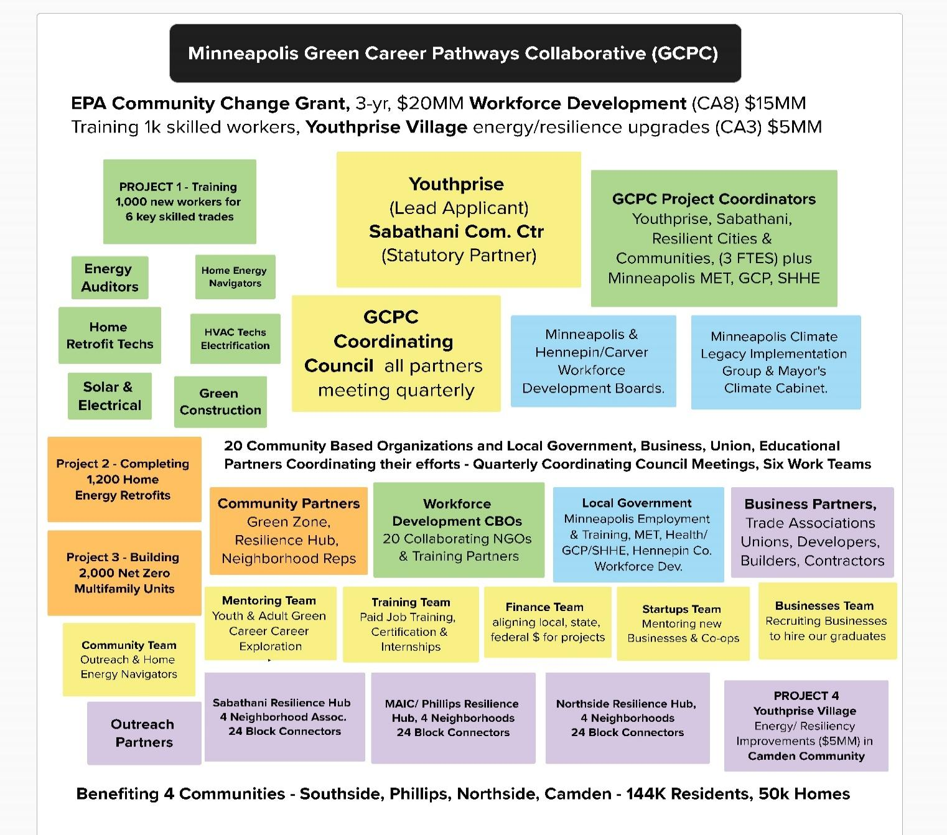
GCPC Leadership Team Roles and Responsibilities
- Our EPA Grant Coordinator (YP/1fte) will oversee contracts with our 20 CBO sub awardees, manage/support/process their reporting and reimbursement-based funds disbursements, keeping things simple, while meeting our federal EPA grant requirements. Our EPA Grant Coordinator will regularly cooordinate with the YP Finance and Compliance Teams will host
Annual GCPC EPA Grantee Orientation Meetings with our 20 subaward collaborating CBOs to ensure our project & outcome reporting and reimbursement-based funding systems are all working well and to offer tips and technical assistance to subrecipients.
- Our GCPC Project Manager (SCC/1fte) will coordinate Project 1 & Project 2 implementation with our Mentoring Team, (8 youth-serving CBOs and 8 adult job search mentoring CBOs) Community Outreach Team (3 Resilience Hub Coordinators, neighborhood outreach partners, block connectors, and home energy navigators) and Training Team (coordinating the efforts of our 3 job training host sites) SCC’s Project Manager will convene/facilitate our
Mentoring Team (monthly) Meetings to facilitate shared learning and coordinate the work of 8 youth-serving and 8 adult mentoring CBOs monthly in person or on zoom. Youthprise/Search Institute staff will convene Youth Serving CBOs quarterly for shared learning/evaluation.) As a result Youth serving CBOs will support 400 youth/year in job readiness/green career exploration and Adult employment CBOs will support 400 area job seekers/year to progress through work readiness, green career exploration, self-assessment and setting career goals and refer/support 400 adults and older youth to participate in GCPC Training Cohort(s) offered by Training partners.
Community Outreach Council (Quarterly) Meetups. SCC’s Project Manager will also support the 3 Resilience Hub Outreach Coordinators to host quarterly Outreach Team meetings at each of the 3 resilience hubs with neighborhood staff, block connectors and home energy navigators serving their zone (all receiving support from City from other sources) to plan spring/summer/fall door knocking and outreach events to annually
- refer 400 youth & adults to green career exploration &/or job training and
- sign up 400 households per year for home energy audits and provide follow up.
- Our GCPC Partnership Manager (RCC/1fte) will coordinate Project 1, Project 2 and Project 3 implementation with our Training, Business, Finance and Startup Teams, by facilitating
  - Training Team (monthly) Meetings with RCC, SCC, CEE, SAOIC, ULTC, MCA/RATC, BMF, MREA, BWM, NS, Just Housing, Minneapolis College, and city, county, business, and union partners to match our job-specific training and certification to meet employer requirements and recruit/support partner businesses, contractors and builders to hire, retain and support the success of GCPC training graduates joining their contractor crews to complete projects that benefit project area residents.
  - Business Team (quarterly) Meetings – with SAOIC, CEE, MCA/RATC, ULTC, RCC, Minneapolis College, and the Minneapolis and Hennepin/Carver Workforce Development Boards and businesses representatives to plan/co-host Business Partner Trainings and coordinate sector-specific employer recruitment/support to hire GCPC training graduates onto their home retrofit and green construction crews.
  - Finance Team (quarterly) Meetings – with SHHE, CPED, CEE, RCC, additional NGOs and state agency partners to line up local, state, federal, utility/private funding for contractors to complete healthy home energy retrofits/net zero multifamily projects.
  - Startup Teams (quarterly) Meetings – with Nexus, SHHE, and interested CPED partner B-TAP and C-TAP Technical Assistance providers to annually mentor/support the successful launch of 3+ local/BIPOC businesses &/or worker coops within our 6 focus industries. The Team will also interview small, local BIPOC owned contractors to hear the challenges/contracting barriers they are experiencing and develop solutions.
Project Work Teams: Our Partnership Manager (RCC/1fte) will convene/facilitate/provide follow up for our Project 2 Team and Project 3 Team (sub-award to RCC will cover these hours.)
Project 2. Healthy Home Energy Retrofit Team (quarterly) Meetings to coordinate co-implementation our work plan to support GCPC Trained Crews and the contractors that hire them complete to annually complete 400 high quality healthy home energy efficiency and electrification retrofits in our project area, completing 1,200 retrofits by 3Q 2007 (CA3/PR1.)
- Project 2. partners City of Minneapolis SHHE, Green Zone Councils, Resilience Hubs, Home Energy Navigators, RCC, CEE, SCC, MCA/RATC and Cooperative Energy Futures,
Our GCPC Partnerships Manager (RCC/1fte) will convene/facilitate GCPC
Project 3. Net Zero Multi Family Construction Team (quarterly) Meetings coordinating collaborative implementation to support GCPC Trained Crews and developers/builders that hire them to build 2,000 Healthy natural gas free, multifamily units (1/3 affordable) while improving indoor air quality, making buildings E.V./solar ready, reducing C & D waste and including our trained apprentices on their construction crews.
- Project 3. Partners: RCC, SAOIC, CEE, BFM, Sustainable Development Collaborative (SDC), Towerside Innovation District (TID), Minneapolis SHHE, MET, CLIIG, CPED, Hennepin Co. TOD, Blue Line Anti-Displacement Coalition, CETUL, Building Dignity and Respect Council

Project 4. Youthprise Village: Building, Energy and Resilience Retrofits (Phase 1 $5MM) The Youthprise Facilities Manager and Construction Project Manager will regularly convene, lead and provide follow up for regular Youthprise Village Construction Team Meetings to coordinate implementation with our
Project 4. Youthprise Village Construction Management Team of experienced partners and professionals working together to ensure the EPA-related capital investments are consistent with the overall vision to maximize the use of the site – which includes input from future tenant partners and the surrounding community.

