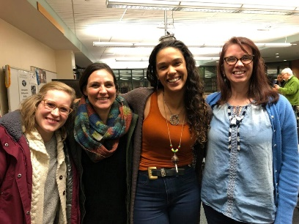  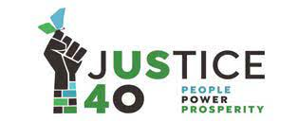  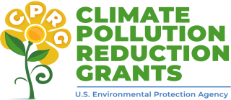 | Collaborative Federal Grants Workshop  At the Green Zones Summit, Sat Feb 17 2024 1:30 to 3:30pm the Mpls Community Connections Conference at the Minneapolis Convention Center  Please RSVP Please RSVP and Fill out our Asset Survey  Overview https://rccmn.co/feb-17-collaborative-federal-grants/  - What – 2-hour Workshop with Topic Break Outs with 100+ participants  - Goal – Get ready to collaboratively apply for & secure major Federal EPA Climate Grants to fund neighborhood & community-based organizations to do outreach to co-implement our Minneapolis Climate Equity Plan  - Audience – staff & volunteers from 50 Minneapolis community-based, EJ and neighborhood nonprofits and relevant City Department Staff  - Topic Break Outs – Co-facilitated by nonprofit & city staff (Air Quality, Efficient Buildings + Solar, Local Food, Resilient Hubs, Tree planting, Transportation, Workforce/Green Jobs, Zero Waste) 1 hour work sessions to connect community, cultural & neighborhood-based organizations working on same topics to send in collaborative proposals with Technical Assistance from (invited) Great Lakes Thriving Communities Technical Assistance Center Blacks in Green
Contact: Sean Gosiewski, RCC 612 250-0389 sean@rccmn.co Kara Thate, RCC (612) 599-4635 kara@rccmn.co
Kyle Samejima Minneapolis Climate Action (612) 849-0725 kyle@mplsclimate.org
Ukasha Dakane FRAYEO 612 707-7591 ukasha.dakane@frayeo.org
Workshop Co- hosts South & Northside Green Zones, Minneapolis Green Teams, Minneapolis Climate Action, Resilient Cities and Communities, FRAEYO, City of Minneapolis Health, Sustainability & NCR staff. We’ll invite groups from last year’s workshop, Project Sweetie Pie, Rusty & the Crew (more groups are welcome!)
Draft Agenda - Welcome, introductions
- Overview of Minneapolis Climate Equity Plan goals & strategies and relevant MN & Federal funding the City has received and plans to apply for. How the city plans to staff grant implementation (including subcontracts.)
- Overview of upcoming Federal grants & how community groups can apply for them with the Great Lakes TcTAC and a panel of community groups that have successfully secured federal or state funding, Example - EPA Community Change Grants $2 billion for 150 projects for $10-20 million each Apply between March & Nov 2024
- Topic/Goal/Strategy Break Outs – (1) review relevant MPLS CEP Goal/Strategy (2) community groups and city/county staff to share what they are working on & hope to work on (3) review upcoming state and federal funding opportunities (4) participants mingle and self-organize and decide to apply individually or together.
- Efficient Buildings – Healthy homes and block wide retrofits, Mpls, Community Power, Unidos, CEE, SRC,
- Air Quality/Health/ Air monitoring volunteers, Front Line Communities, EJ Table
- Local Food Systems – Project Sweetie Pie, EPNI Little Earth Farm, Frogtown Farm, YFP, Home Grown, etc.
- Zero Waste – Kelly Kish, City of Minneapolis, Joe Vital, Hennepin Co., Nazir Kahn, MN Zero Waste Coalition
- Resilience Hubs, Tree Planting, Transportation, Job Training/Small Business Development
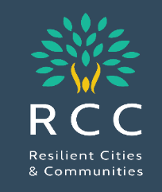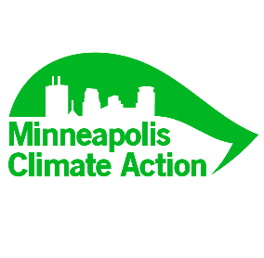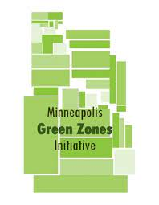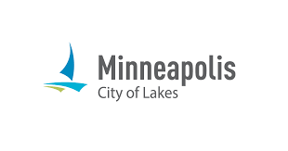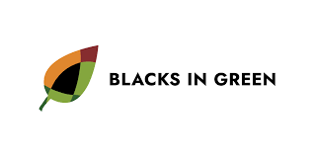

Timeline and tasks to co-organize the workshop
December  Mon Dec 11 3pm GZ Summit Planning Team - share workshop idea  Week of Dec 18 – meet with partners to plan workshop | January  Topic Session Co-Hosts  (relevant NGO & City staff)  Invite groups they work and use their channels to invite interested NGOs to participate in their 2/17 breakout session | February  Topic Session Co-Hosts  Meet 1 on 1 with groups to explore which Mpls CEP goals & strategies they want to work on and research relevant state & federal funding RFPs | March Nonprofits meet by topic, pick a lead group to apply & begin to co-write proposals.  City of Minneapolis – includes community outreach in new federal grant proposals

Funding Opportunities EPA Carbon Pollution Reduction Implementation Grants (Due April 1) Local Governments apply with the MPCA &/ or Met Council, Cities apply ($200 to $500 million) https://engage.eqb.state.mn.us/climate-priorities
EPA Community Change Grant Applications, Rolling Basis March 2024 until Nov 2024
www.epa.gov/inflation-reduction-act/inflation-reduction-act-community-change-grants-program
- Two-track Submission Processes: Applications can be submitted under two separate tracks depending on the project scope and funding requested.
  - Track I, Community-Driven Investments for Change, is expected to award approximately $1.96 billion for 150 projects for $10-20 million each.
  - Track II, Meaningful Engagement for Equitable Governance, is expected to award approximately $40 million for 20 projects for $1-3 million each.
- Technical Assistance: Applicants can request, EPA’s Community Change Grants Technical Assistance webpage.

Metro Cities & Communities Federal Climate Grants Tracker, Please Keep our Shared Google Sheet Current THANKS kara@rccmn.co
Minneapolis Climate Equity Plan Implementation Strategies | Lead Contacts - City staff and nonprofit & partners | Current City funding  Franchise fee & grants | New Grants  City applies | New Grants  Nonprofits apply
AIR.2.4 Pilot: residential programs to monitor & improve indoor and outdoor air quality | SHHE, MPCA, SRC,  Clean Air MN, EJ Table  Cumulative Impacts | City of Mpls EPA Air Monitoring grant
AIR.2.6 Program: Increase neighborhood tree planting on blocks experiencing high levels of outdoor air pollution | Public Works  MPRB  Great River Greening | Mpls $8 million forestry (over 5 years)  EPA $10 million 5-yr to  Great River Greening | New MN DNR Forestry Grants
HEH.3.2 TISH Energy Reports  HEH.3.4 home electrification | SHHE, CPED, CEE, CERTS,  Electrify Everything MN | MN Dept of Commerce  IRA Tax Credits
HEH.1.3 Pilot: Begin whole home weatherization and electrification retrofit pilot | SHHE, CPED  CEE, SRC  Community Power, | $1.4 million in ARPA and EECDBG funding.  IIJA LIHEAP Funds | Energy Efficiency Navigators Feds Awarded $400k (TCEEC) MN CUB  CEF Community Power
Healthy Food Access/ Resilience  Home Grown Food Council | EPIC Indoor Farm  Sweetie Pie, etc. YFP, etc.
Zero Waste Mpls & Hennepin Co and Metro-wide Zero Waste Plans  Organics, Plastics, etc. | Minneapolis Public Works  Hennepin Co/ Tri County  Eureka, EJ Table, Legislators | EPA City of Minneapolis  $4 million SWIFR grant, | EPA turned down Hen Co $20 million REO (can re-apply)  ILSR was approved for REO.
Bike Ped Safety, Traffic Calming, vision Zero installing traffic safety | Minneapolis Public Works,  Our Streets, Sierra Club | Biden $20 million for Mpls safety measures at | Feds Award $ 2 million to ReConnect Rondo, City of St. Paul

