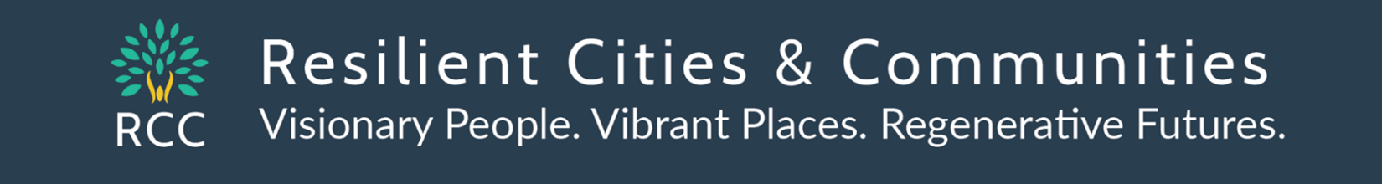
Sean Gosiewski, Executive Director, RCC 612 250-0389 sean@rccmn.co
https://rccmn.co/collaborative-climate-implementation/
Invitation for Minneapolis Neighborhood Environment Committees & Community Groups to help implement our new Minneapolis Climate Equity Plan by helping with
- strengthening City-Wide Action Campaigns, City-Community Collaborative fundraising/Federal Grants
- neighbor to neighbor & business Outreach to share City-Wide Action Campaigns to invite residents & businesses to take specific actions http://rccmn.co/minneapolis
Let’s build up our neighborhood outreach capacities together!
 | Current Outreach Capacities | 2024 – Strengthen city-wide action campaigns |  | 2025 – Share our updated city-wide action campaigns
BASIC LEVEL | Neighborhood Green Teams & Community Partners engage Neighbors & businesses to take action by developing their own campaigns and by sharing  City-wide action campaigns (Spring Tree Sale, Adopt a Drain, etc.) shared in Minneapolis Sustainability E-News  Minneapolis Green Teams Meet Ups  Quarterly City-wide meet ups  (MCA, RCC, Frayeo) volunteers & staff  Sharing ideas to strengthen teams  and sharing action campaign ideas | Neighborhood Green Team volunteers & nonprofits meet with City Staff in Strategy Teams to strengthen City-Wide Action Campaigns i.e. home energy squad, IRA Ambassadors.  Neighborhoods ask NCR, SHHE, City Council to include 1k Neighborhood Climate Liaison Stipends in 2025 City Budget  Mpls Green Teams City-wide Meet ups invite SHEE Staff, CEAC & EVAC to share updates |  | Neighborhood Associations begin receiving annual 1k Stipends for a  Neighborhood Liaison for the Climate Equity Plan (volunteer or staff) on top of $15k NCR Contract  Neighborhood Green Teams Share  City-Wide Action Campaigns with neighbors and busineses  Mpls Green Team Meet ups  Quarterly City-wide meet ups AND  Ward based meet ups with neighborhood green teams & CBOs
MID  LEVEL |  | 2024 & 2025 – Neighborhood Associations & non-profits contribute In Kind volunteer and staff time to collaborate with City Staff on  City-Wide Strategy Teams to  - strengthen City-Wide Action Campaigns  - develop & launch Strategy-Specific Pilot Projects &  - brainstorm & develop outcomes, deliverables and training for the strategy specific outreach contract opportunities  City-Community Collaborative Federal Grants Workshop – Feb 2024  - City-Sponsored Federal & State Grant Applications (could request outreach $ and $ for specific local projects)  - Community-Based, Nonprofit Sponsored Fed & State Grant Apps (Smaller nonprofits could partner with larger nonprofits to send in Topic-Specific grants for local projects & outreach city-wide
ADVANCED LEVEL  Paid Outreach Contracts |  | Launch PAID OUTREACH CONTRACTS with interested Neighborhood & Community Based Organizations (to pay for existing staff &/or new staff)  - NGOs sign up for streamlined contracting with Mpls & Hennepin Co.  - NGOs receive notices from city, county & large nonprofits on strategy- specific outreach contracts, and choose ones they want to OPT IN for
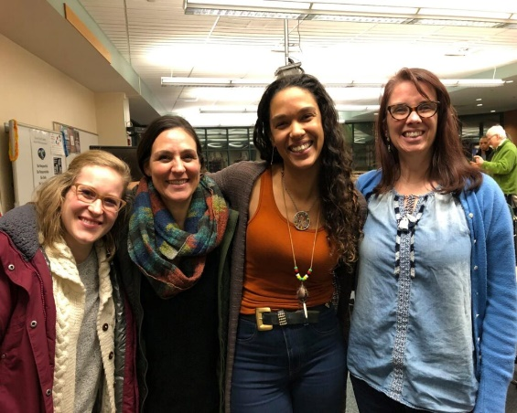 |  |  | Collaborative City-Community Implementation  of our Minneapolis Climate Equity Plan  Let’s brainstorm how SHHE staff CEAC, EVAC, SHEE and neighborhood & community partners can co-launch  (1) Collaborative Strategy Teams,  (2) Collaborative Grants  (3) Collaborative Outreach – neighborhood & ward teams,  - city wide action campaigns,  - outreach contracts  (4) Collaborative Strategy Engagement
Possible collaborative partners SHHE staff, CEAC, EVAC, Home Grown Council, Hennepin County, State Agencies
Minneapolis Green Teams, Just Transition, Cumulative Impacts Coalitions, Great Lakes TcTAC, Blacks in Green TcTAC
ONE - Collaborative Strategy Teams City staff- agency and nonprofit staff, community & business partners – meeting as needed (similar to teams that developed the Climate Equity Plan strategies) i.e. Air, Food, Healthy Homes, Trees, to
- Work to solve urgent Issues together (i.e. Smith Foundry Air Permit Violations) Strategy AIR.2. Co-convene, quarterly City/ county/community air quality working group meetings to maintain mutual transparency & accountability to act on air quality data. Lead(s): SHHE, MPCA, and Hennepin County
- Co-Develop and Share city-wide campaigns to engage residents and businesses - i.e. HEH.3.4 Pilot: Engage in an educational home electrification campaign in concert with metro cities. mncee.org/electrifyeverythingmn
- Co-Develop & Roll out Pilot Projects (with strategy maps, building on insights from previous work) and Strategy Specific Outreach Contracts (with roles and deliverables for paid sub-contractors) - i.e. HEH.1.3 Pilot: Begin whole home weatherization and electrification retrofit pilot to understand sequencing, build knowledge, develop work force, and coordination with metro cities’ initiatives using $1.4 million ARPA & EECDBG federal $.

TWO - Collaborative Grants, (see below) to co-implement Phase I Strategies (including outreach) Let’s Coordinate between the City of Minneapolis, Hennepin Co, interested nonprofits & CBOs with SHHE UMN Great Lakes TC TAC, Mpls Fdn, McKnight,
- to track, review and coordinate applying for current and future funding opportunities (the City or County can apply for some while coalitions of community groups can apply for other grants) We are missing out on applying for relevant RFPs (EPA EE 2023 $50k deadline just passed) BIG RFPs are coming up soon -
- EPA CPRG w MPCA & Met Council (Governments apply) https://engage.eqb.state.mn.us/climate-priorities
- EPA Community Change (CBOs) www.epa.gov/inflation-reduction-act/inflation-reduction-act-community-change-grants-program

THREE - Collaborative Outreach -SHHE, CEAC, EVAC, Just Transition & Minneapolis Green Teams working together to engage
Neighborhood Green Teams, Ward Teams & community-based groups to City Departments, Partners & City Council Members to engage neighbors and businesses in taking action to implement Phase I strategies through -
- City-wide education/action campaigns, to engage neighbors i.e. home energy squad, tree planting, etc.
- Facilitating City and County Strategy-Specific Outreach Contracts with neighborhood associations, nonprofits & CBOs

FOUR - Collaborative Strategy Engagement (option to explore) Insight Vision Strategy Engagement Platform with training/coaching to maintain mutual accountability and transparency between city departments, implementation partners, NGOs, CBOs, commissions as we collaboratively implement the Minneapolis Climate Equity Plan & manage & report on federal grants. St. Paul Climate Action Dashboard. Duluth is using Get Green
Possible Shared platforms for tracking goals benchmarks actions strategy maps team members funding sources project outcomes/case studies reporting

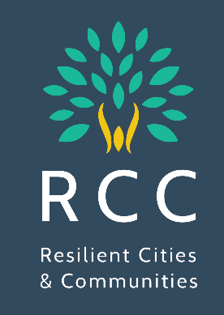 | Let’s Co-Organize a City-Community Federal Climate Grant Workshop  - When – February 2023  - Why - access state & federal funds to support neighborhood climate outreach  - Co- hosts - CEAC, EVAC, SHHE & NCR staff, U of MN Great Lakes TcTAC, RCC Mpls Green Teams, Unidos, Just Transition Coalition, Hennepin Co., MPCA, etc.  - Participants - Partner nonprofits, community based & EJ organizations & neighborhood associations, to apply for state and federal funding related to Minneapolis Climate Equity Plan Strategies.
Draft Agenda - Welcome, introductions
- Overview of Minneapolis Climate Equity Plan goals & strategies and relevant MN & Federal funding the City has received and plans to apply for. How the city plans to staff grant implementation (including sub contracts.)
- Overview of upcoming Federal grants & how community groups can apply for them with the Great Lakes TC TAC and a panel of community groups that have successfully secured federal or state funding
- Topic/Goal/Strategy Break Outs – (1) review relevant MPLS CEP Goal/Strategy (2) community groups and city/county staff to share what they are working on & hope to work on (3) review upcoming state and federal funding opportunities (4) participants mingle and self-organize and decide to apply individually or together.
Example Funding Opportunities
- Community Change www.epa.gov/inflation-reduction-act/inflation-reduction-act-community-change-grants-program
- EPA Carbon Pollution Reduction Implementation Grants (Due April 1) MPCA, Met Council, Cities apply ($200 to $500 million) https://engage.eqb.state.mn.us/climate-priorities
Minneapolis Climate Equity Plan Implementation Strategies |  | Lead Contacts - City staff and nonprofit & partners | Current City funding  Franchise fee & grants | New Grants  City applies | New Grants  Nonprofits apply
AIR.2.4 Pilot: residential programs to monitor & improve indoor and outdoor air quality |  | SHHE, MPCA, SRC,  Clean Air MN, EJ Table  Cumulative Impacts | City of Mpls EPA Air Monitoring grant
AIR.2.6 Program: Increase neighborhood tree planting on blocks experiencing high levels of outdoor air pollution |  | Public Works  MPRB  Great River Greening | Mpls $8 million forestry (over 5 years)  EPA $10 million 5-yr to  Great River Greening | New MN DNR Forestry Grants
HEH.3.2 TISH Energy Reports  HEH.3.4 home electrification educational campaign |  | SHHE, CPED, CEE, CERTS,  Electrify Everything MN  Coalition of metro cities | MN Dept of Commerce  IRA Tax Credits
HEH.1.3 Pilot: Begin whole home weatherization and electrification retrofit pilot |  | SHHE, CPED  CEE, SRC  Community Power, | $1.4 million in ARPA and EECDBG funding.  IIJA LIHEAP Funds
Healthy Food Access/ Resilience  Home Grown Food Council  Resilience Hubs |  | EPIC Indoor Farm  Little Earth Farm  Sweetie Pie, etc.
Zero Waste Mpls & Hennepin Co and Metro-wide Zero Waste Plans  Organics, Plastics, etc. |  | Minneapolis Public Works  Hennepin Co/ Tri County  Eureka, EJ Table, Legislators | EPA City of Minneapolis  $4 million SWIFR grant,

