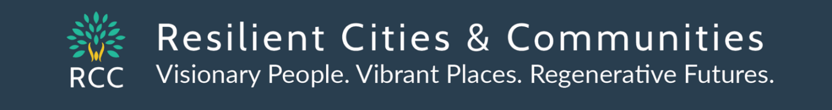

Resource Package – RCC Climate Action Conference October 6, 2022

Keynote Video - Regional Indicators Initiative Summary – MN Cities Progress in Reducing Greenhouse Gas Emissions & Emerging Opportunities
Becky Alexander, Senior Researcher
Regional Indicators Initiative/LHB
612.752.6933 becky.alexander@lhbcorp.com

Presentation Highlights:
Efficient Buildings
Transportation
Energy
Zero Waste

Resources from RCC Topic Sessions - https://rccmn.co/the-network/topic-teams/
- Buildings Topic Session https://rccmn.co/buildings/
- Energy Topic Session https://rccmn.co/energy/
- Green Jobs Topic Session https://rccmn.co/green-jobs/
- Resilience Topic Session https://rccmn.co/resilience/
- Transportation Topic Session https://rccmn.co/transportation/
- Zero Waste Topic Session https://rccmn.co/zero-waste/

Resources from RCC County Cluster Sessions https://rccmn.co/county-clusters/
- Anoka, Dakota, Hennepin, Ramsey, Washington, SE MN, NE MN

Regional Indicator Initiative Tools and Resources https://www.regionalindicatorsmn.com/resources
In addition to providing city-wide data, the Regional Indicators Initiative offers tools and resources to assist local government elected officials, staff, and community members in climate planning and action.

Climate and Energy Planning Resources
- A wedge diagram tool for energy and greenhouse gas reduction planning with an associated menu of feasible city actions
- A brief guide on how to incorporate energy and/or climate resilience in a city's request for proposals
- An energy planning guide and workbook for use in comprehensive planning and/or energy planning efforts
- An example analysis of energy existing conditions documenting a city’s energy use profile and available energy resources
- Example local government energy goals
- A solar energy calculator to assist in setting solar energy development goals

Climate and Energy Planning Webinars
- "Regional Indicators Initiative: Data and Tools for Community Climate Action" (September 2022): Recording and Slides
- "Tools for Local Government Energy Champions" (October 2017): Recording and Slides

Climate and Energy Planning Stories
The Minnesota Sustainability Index - an overview of governmental units in Minnesota that have analyses, goals, and/or plans related to climate, energy, and equity

New Resources available to support your city to achieve its climate action goals on time
- MN GreenStep Cities Gold Leaf Program (Coming Soon)
An expansion for the Minnesota GreenStep Cities and Tribal Nations programs to challenge, assist, and recognize local climate action (Kristin Mroz, GreenStep Cities Coordinator, MPCA,
kristin.mroz-risse@state.mn.us, (651) 757-2793)

- Met Council Climate Action Scenario Planning Tool (Coming in early 2023)
New Scenario Planning Tool to support cities to plan and prioritize actions to cut GHGs
(Mauricio Leon, Met Council Indicators, Mauricio.Leon@metc.state.mn.us)

- Partners in Energy

Deadline for Signing Up to Participate – January 15 and July 15
Partners in Energy is a program from Xcel Energy that supports the communities we serve by helping them develop and implement these energy plans. Each community has its own unique energy needs and priorities, and Partners in Energy services are tailored to complement each community’s vision.

Partners in Energy is for cities included in the Xcel Energy Service Territory Application Form
(Contact Tami Gunderzik Tami.Gunderzik@xcelenergy.com or Deirdre Coleman dcoleman@mncee.org https://mn.my.xcelenergy.com/s/partner-resources/municipalities/partners-in-energy )

- Efficient Buildings Collaborative

Open for participation by cities state-wide supporting cities to adopt and implement commercial energy benchmarking policies and sustainable building policies
The Efficient Buildings Collaborative brings together the county, cities and buildings owners to do energy benchmarking. Energy benchmarking is the process of monitoring and reporting the energy use of a building. It allows comparison of buildings’ energy use to similar buildings or buildings’ past performance.

Cities can get help from Hennepin County adopting an energy benchmarking ordinance. They can also get help developing and implementing the program.

https://www.hennepin.us/your-government/projects-initiatives/efficient-buildings-collaborative
(Leah Hiniker Sustainability manager 612-543-1219 leah.hiniker@hennepin.us)

Resources from RCC Topic Sessions - https://rccmn.co/the-network/topic-teams/

Buildings Topic Session https://rccmn.co/buildings/

Facilitator - Kristin Mroz, GreenStep Cities Coordinator, (651) 757-2793 kristin.mroz-risse@state.mn.us
Buildings Background Slides
Buildings High Impact Actions

Resource staff
- Katie Jones, Community Program and Policy Manager, CEE 612-741-0596 kjones@mncee.org
- Leah Hiniker, Energy Manager, 612 543-1219 leah.hiniker@co.hennepin.mn.us
Update on Hennepin Co Efficient Buildings Collaborative and how cities can get involved
- Luke Hollenkamp, Mpls Sustainability office 612-673-2349 luke.hollenkamp@minneapolismn.gov
Minneapolis policies & funding, benchmarking, TISH, SBP, Green Cost Share https://www2.minneapolismn.gov/sustainability/
- Kurt Schultz, City of St. Paul, PED, 651 266-6590 kurt.schultz@ci.stpaul.mn.us
St. Paul Sustainable Building Policies, benchmarking, large sites, TISH https://www.stpaul.gov/sustainable-building-ordinance

RCC Buildings Topic Team Leader
Kevin Brauer, 612 868-0365 kevin@homeperformancestrategies.net

Next Meeting
RCC Buildings Topic Team - Thurs Nov 17 - Noon to 1pm on Zoom

Networked Geothermal Webinar Recording
Networked geothermal for heating and cooling has been making waves recently among clean energy advocates, researchers, and utilities as the “next big thing” in the energy transition. On September 21, the Energy We Can’t Afford Coalition and special guests from Minnesota to Massachusetts to dug into this new technology.
Given its potential for support across a wide range of stakeholders, geothermal microgrids and district systems could play a key role in de-carbonization of cold climates and provide an opportunity for larger scale implementation of geothermal by utilities. And the good news is that geothermal systems are already up and running right here in Minnesota! https://fresh-energy.org/event/how-networked-geothermal-can-help-get-minnesota-off-fossil-gas

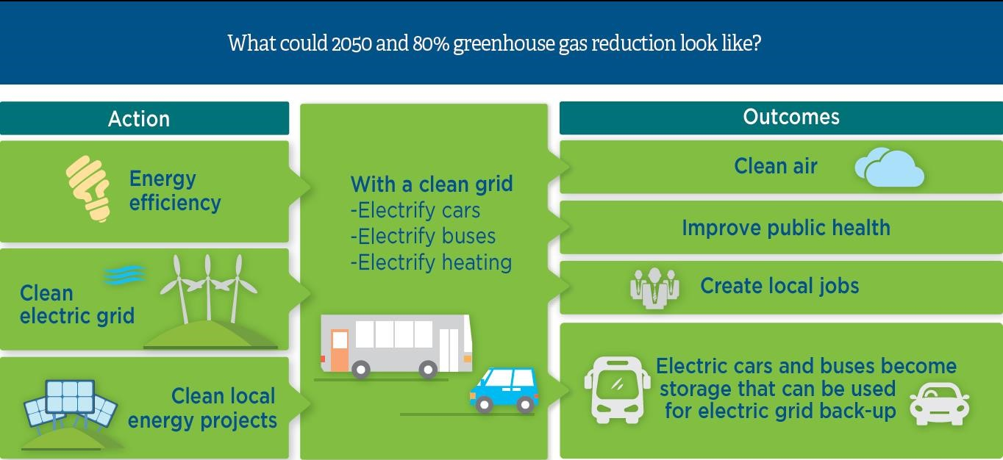

Transportation Topic Session https://rccmn.co/transportation/

Facilitator - Frank Douma, Humphrey School 651-690-4344 douma002@umn.edu

Transportation RII Background Slides
Transportation High Impact Actions

Resource staff

- KC Atkins, Hennepin Co Public Works. 612-596-0354 kc.atkins@hennepin.us - Update on Hennepin County’s initiative to reduce vehicles miles traveled https://www.hennepin.us/-/media/hennepinus/business/work-with-hennepin-county/transportation-planning/comp-plan-2040-2-transportation.pdf
- Gina Mitteco Dakota Co Multi-Modal Transportation Manager 952 891-7114 gina.mitteco@co.dakota.mn.us - How Dakota Co is partnering with cities on the Robert Street BRT and bike/ped trail connections https://www.co.dakota.mn.us/Transportation/Transit/RobertStreet/Pages/default.aspx
- Abdullahi Abdulle MN DOT Transportation Equity (612) 607-4971 Abdullahi.abdulle@state.mn.us
- MNDOTs Transportation Equity Initiatives www.dot.state.mn.us/planning/program/advancing-transportation-equity/
- Anna Johnson Policy & Public Affairs Fresh Energy 651 294 7145 Johnson@fresh-energy.org
Update on Federal IIJA grants & IRA tax credits & relevance for EVs and more flexible transportation spending https://fresh-energy.org/game-changing-policies-in-the-inflation-reduction-act

- Mauricio Leon, Met Council Indicators Mauricio.Leon@metc.state.mn.us
Update on the new Scenario Planning Tool to support cities to prioritize actions to cut GHGs https://rccmn.co/wp-content/uploads/2022/08/MetCouncil_ClimateActionPlanningTool_Covered_Strategies.pdf
- Peter Lindstrom CERTS, Met Council (651) 324-4831 plindstr@umn.edu
How Met Council is coordinating with cities on VMT reduction, BRT and transit electrification https://metrocouncil.org/Transportation/Projects/Transit-Projects.aspx

- Connie Bernardy Active Living Ramsey Communities 651-748-2500 Connie.Bernardy@co.ramsey.mn.us
Ramsey Co Public Works & Parks are partnering w cities in 3 to 4 conversations & bike/ped connections https://www.ramseycounty.us/residents/roads-transportation/future-road-projects/transportation-improvement-program

RCC Transportation Topic Team Leaders - convening our next RCC Buildings Topic Team Zoom Call
- Jim Erkel, (651) 353-5935 cjerkel@comcast.net Phil Muessig 612 437-8415 pmuessig@yahoo.com

Next Meeting
RCC Transportation Topic Team - Thurs Nov 10 Noon to 1pm on Zoom

New Report: Estimating the Greenhouse Gas Impact of Federal Infrastructure Investments in the IIJA
James Bradbury, Georgetown Climate Center, james.bradbury@georgetown.edu
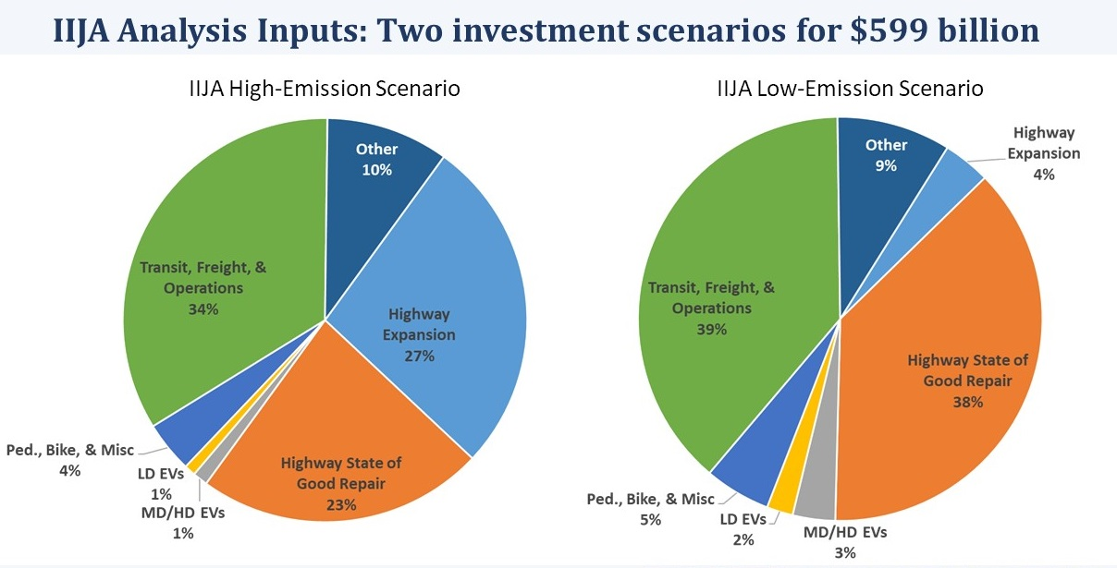

Energy Topic Session https://rccmn.co/energy/

Energy RII Background Slides
Energy High Impact Actions

Facilitator - Leo Ndiaye, RCC Board Chair, 612 203—1952, leondiaye200@gmail.com

Resource staff

- Stacy Miller, City of Minneapolis Sustainability, 612 673-3110 stacy.miller@minneapolismn.gov
- Peter Lindstrom CERTS (651) 324-4831 plindstr@umn.edu

Green Jobs Topic Session https://rccmn.co/green-jobs/

Green Jobs High Impact City Actions

Facilitator - Michael Krause, 612) 229-7702 michaelkrause61@yahoo.com

Resource staff

- Sarah Northrup, CEE Workforce Program Manager 612-335-5879 snorthrup@mncee.org
- Emilia Gonzalez Avalos, Unidos emilia@unidos-mn.org
- Robert Blake, Executive Director, Native Sun 612-669-1165 robertblake22@gmail.com (Governor’s Workforce Dev. Board)
- Elena Foshay, Director of Workforce Development for the City of Duluth. elenafoshay@gmail.com
- Metro Blooms (651) 699-2426 info@metroblooms.org metroblooms.org/landcare-services/#sustainable-landcare-training-academy
- Scott D. Cole CEO / Co-founder, Collectivity 651-276-5775 scott.cole@collectivity.coop
- Minneapolis - Marie Larson - Industry Relations Training Manager 612.673.5292 marie.larson@minneapolismn.gov
- St. Paul - Russ Stark Chief Resilience Officer 651 266-8511 Russ.stark@ci.stpaul.mn.us

Resilience Topic Session https://rccmn.co/resilience/

Resilience High Impact Actions
Resilience Jam Board
Hennepin County Natural Resources Plan Update

Facilitator - Laura Milberg, MPCA (651) 757-2568 laura.millberg@state.mn.us

Resource staff

- John Evans Hennepin Co E & E Assistant Director (612) 348-4046 john.evans@hennepin.us
Natural Resources Plan Update and how to get involved https://www.hennepin.us/natural-resources-plan
- Matt Metzger, P.E. Barr Engineering 952-832-2830 mmetzger@barr.com
Sharing examples of how Barr is supporting cities to develop climate resiliency and green infrastructure https://www.barr.com/Insights/Insights-Article/ArtMID/1344/ArticleID/386/Establishing-climate-change-adaptation-strategies
- Eric Wojchik, Met Council Eric.Wojchik@metc.state.mn.us - climate vulnerability assessment tools https://metrocouncil.org/Communities/Planning/Local-Planning-Assistance/CVA.aspx
and growing shade tool https://metrocouncil.org/News-Events/Communities/Newsletters/Growing-Shade-tool-2022.aspx

Zero Waste Topic Session https://rccmn.co/zero-waste/

Zero Waste RII Background Slides
Zero Waste High Impact Actions

Facilitator - Lucy Mullany, Director of Policy & Advocacy. 612 669-2783 LucyM@eurekarecycling.org

Resource staff

- Ben Knudson, Hennepin County Energy and Environment 612 596-1176 Ben.Knudson@hennepin.us - Update on Hennepin Co Zero Waste Plan Update https://www.hennepin.us/climate-action/what-hennepin-is-doing/zero-waste-plan
- Kellie Kish, City of Minneapolis Recycling Coordinator 612-673-3536. Kellie.Kish@minneapolismn.gov - Update on Minneapolis Zero Waste Plan https://www.minneapolismn.gov/government/programs-initiatives/zero-waste/

Zero Waste Opportunities

$139,000 available for waste reduction and reuse grants
The Minnesota Pollution Control Agency (MPCA) is offering Environmental Assistance (EA) grants for projects working to expand waste reduction and reuse, rental, and repair efforts around the state. Applications are due no later than 4 p.m. on Thursday, November 17, 2022. https://www.pca.state.mn.us/business-with-us/grants-and-loans

Extended Producer Responsibility Legislation
The Partnership on Waste and Energy, a collaborative effort of Hennepin, Ramsey, & Washington counties, is collaborating with the Product Stewardship Institute https://www.productstewardship.us/ https://recyclingandenergy.org/partnership-epr-for-packaging/

Update on Federal Funding Opportunities https://rccmn.co/expanding-funding/

Federal Funding Opportunities for Local Decarbonization
https://cityrenewables.org/ffold/
Navigating federal funding for local climate action and making strategic decisions on how to best pursue opportunities can be overwhelming and challenging. This tool helps local governments prioritize and leverage existing federal funding to advance system-wide energy transition goals—from block grants and technical assistance to competitive grants and loans. Use the filters below to filter available funding sources automatically and focus on the funding sources relevant to your project, goals, and community.

Resource People

- Daniel Lightfoot, League of Minnesota Cities IGR Representative & Federal Relations Manager, (651) 281-1295 gro.cml@toofthgild
- Anna Johnson Fresh Energy, Senior Policy & Public Affairs Assoc, 651 294-7145, Johnson@fresh-energy.org

MNDOT
- Funding opportunities landing page
- State Aid for Local Transportation
- Upcoming Notice of Funding Opportunity Announcements in 2022

US Department of Transportation
- USDOT Navigator
- Competitive grant programs local governments can apply to directly
- Landing page for funding and resources

MN Department of Employment and Economic Development
- IIJA broadband funding
- Infrastructure funding (state and federal)

White House BUILD Resources
- White House BUILD Guidebook
- White House Technical Assistance Guide
- White House BUILD Rural Playbook
- BUILD Tribal Playbook

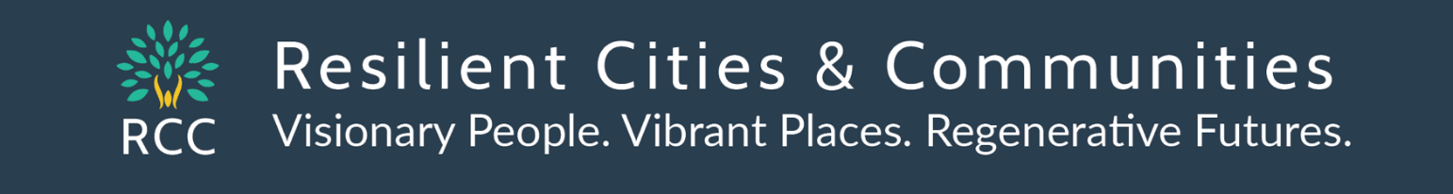

Join our Resilient Cities and Communities Network! https://rccmn.co/the-network/
Our Focus - supporting citizens, commissions, cities and counties to work together to achieve our 2030 and 2050 climate goals while building equitable, vital, resilient communities.
- City Action Teams RCC supports Citizen Coalitions and City Sustainability Commissions to partner with their City Staff and City Council, to work effectively together, and to set and meet community-wide sustainability, energy, and climate goals. https://rccmn.co/city-action-teams-2/
- County Clusters help advance the work of your city’s commissions & citizen networks and help strengthen city-county collaborative initiatives https://rccmn.co/county-clusters/
- Topic Teams Add your expertise to a Topic Team - to support cities and counties in taking high impact actions https://rccmn.co/the-network/topic-teams/
  - City Teams City Commissions, Staff & Elected Leaders Implementing Climate Action Work Plans
  - County Clusters - City teams meeting quarterly by county to support one another’s next steps.
  - Topic Teams - Resource partners supporting cities & counties to implement high impact actions for Buildings, Energy, Green Jobs, Resilience, Transportation and Zero Waste
  - Policy Teams advance state & federal funding and policy solutions
- Peer Learning Networks - connecting through conversations, topic workshops, one on one calls to support one another https://rccmn.co/peer-learning-networks/
- City Commission Volunteers MN BIPOC Local Elected Leaders Network
- City Council Members & Mayors active with climate solutions – MN Cities Climate Caucus
- YOUTH Leader Network Natural Resources/Friends of Parks, Human Rights Commissions

- Become a RCC Business Partner - Individuals, cities, counties, nonprofits and businesses can join RCC as Annual RCC Network Sponsors/Partners (sliding scale based on organization’s size)
- Connect and collaborate with cities, counties, nonprofits, agencies & businesses active with our RCC Network
- Guidestar – Gold Transparency

Resilient Cities and Communities - Staff & Board https://rccmn.co/about/
- Sean Gosiewski, Executive Director, 612 250-0389, sean@rccmn.co
- Maria Tomczik, Project Coordinator, maria@rccmn.co

Board of Directors
- Leo Ndiaye, RCC President Minneapolis, MN 612-203-1952 leo@rccmn.co leondiaye200@gmail.com Coordinator, MN BIPOC Local Elected Leaders Network
- Mia Beste, RCC Vice President (507) 358-7892 mia.m.beste@gmail.com Nokomis East Neighborhood
- Steve Jorissen, Ph.D. RCC Secretary (651) 308-1015 sajorissen@gmail.com PhD Adjunct Professor of Chemistry at St Thomas. V.H. Planning Commission, NE Metro Climate Action , Ramsey County Cluster
- Daniel Katzenberger, RCC Treasurer, 612 327-4210 dan@katzenberger.org E.P. Sustainability Commission,
- Huda Ahmed, RCC Board Member Blaine, MN 952 217-0191 huda@transformational-solutions.com Founder, Transformational Solutions LinkedIn Board member, Isuroon, Strong Women, Strong Communities
- Ian Oundo, RCC Board Member (952) 607-9784 ian.oundo@gmail.com Coon Rapids, Sustainability Commission President, Ugandan Association of Minnesota

