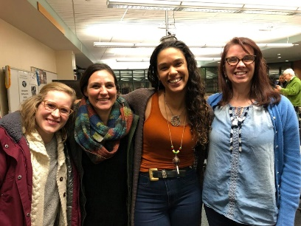  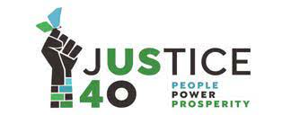  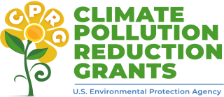 |  | Let’s Co-Organize a Collaborative Federal Climate Grants Workshop  At the Green Zones Summit, Sat Feb 17 2024 at the Mpls Community Connections Conference at the Minneapolis Convention Center https://rccmn.co/minneapolis/  - What – 2-hour Workshop with Topic Break Outs with 100+ participants  - Goal – Get ready to collaboratively apply for & secure major Federal EPA Climate Grants to fund neighborhood & community-based organizations to do outreach to co-implement our Minneapolis Climate Equity Plan  - Audience – staff & volunteers from 50 Minneapolis community-based, EJ and neighborhood nonprofits and relevant City Department Staff  - Topic Break Outs – Co-facilitated by nonprofit & city staff - 1 hour work sessions to connect community, cultural & neighborhood-based organizations working on same topics to send in collaborative proposals & work with city staff to be included in city grant applications
Contact: Sean Gosiewski, RCC 612 250-0389 sean@rccmn.co or Kara Thate, RCC (612) 599-4635 kara@rccmn.co
Workshop Co- hosts South & Northside Green Zones, Minneapolis Green Teams, Minneapolis Climate Action, Resilient Cities and Communities, FRAEYO, City of Minneapolis Health, Sustainability & NCR staff. We’ll invite groups from last year’s workshop, Project Sweetie Pie, Rusty & the Crew (more groups are welcome!)
Technical Assistance (invited) U of MN Great Lakes Thriving Communities Technical Assistance Center
Timeline and tasks to co-organize the workshop
December  Mon Dec 11 3pm GZ Summit Planning Team - share workshop idea  Week of Dec 18 – meet with partners to plan workshop | January  Topic Session Co-Hosts  (relevant NGO & City staff)  Invite groups they work and use their channels to invite interested NGOs to participate in their 2/17 breakout session |  | February  Topic Session Co-Hosts  Meet 1 on 1 with groups to explore which Mpls CEP goals & strategies they want to work on and research relevant state & federal funding RFPs | March  Nonprofits meet by topic, pick a lead group to apply & begin to co-write proposals.  City of Minneapolis – describes community partnerships in new federal grant proposals
Draft Agenda - Welcome, introductions
- Overview of Minneapolis Climate Equity Plan goals & strategies and relevant MN & Federal funding the City has received and plans to apply for. How the city plans to staff grant implementation (including subcontracts.)
- Overview of upcoming Federal grants & how community groups can apply for them with the Great Lakes TcTAC and a panel of community groups that have successfully secured federal or state funding, Example - EPA Community Change Grants $2 billion for 150 projects for $10-20 million each Apply between March & Nov 2024
- Topic/Goal/Strategy Break Outs – (1) review relevant MPLS CEP Goal/Strategy (2) community groups and city/county staff to share what they are working on & hope to work on (3) review upcoming state and federal funding opportunities (4) participants mingle and self-organize and decide to apply individually or together.
- Efficient Buildings – Healthy homes and block wide retrofits, Mpls, Community Power, Unidos, CEE, SRC,
- Air Quality/Health/cumulative air impacts, - Air monitoring volunteers, Front Line Communities, EJ Table
- Local Food Systems – Home Grown Food Council, Project Sweetie Pie, EPIC, Little Earth Farm, etc.
- Zero Waste – Kelly Kish, City of Minneapolis, Joe Vital, Hennepin Co., Nazir Kahn, MN Zero Waste Coalition
- Resilience/ Tree Planting/ Habitat, Transportation, Workforce & Small Business Development MORE TOPICS
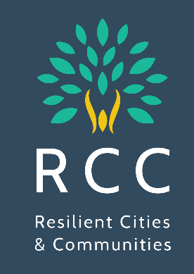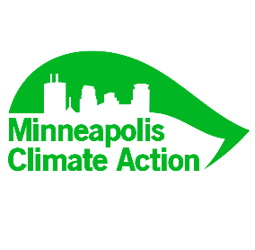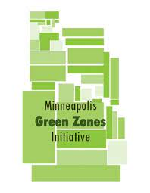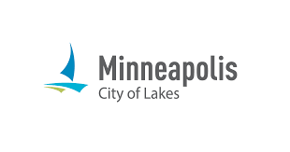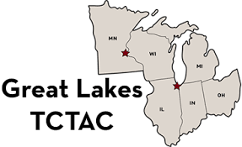
U of MN TcTAC Invited
Example Funding Opportunities
EPA Carbon Pollution Reduction Implementation Grants (Due April 1) Local Governments apply with the MPCA &/ or Met Council, Cities apply ($200 to $500 million) https://engage.eqb.state.mn.us/climate-priorities
EPA Community Change Grant Applications, Rolling Basis until Nov 2024
www.epa.gov/inflation-reduction-act/inflation-reduction-act-community-change-grants-program
- Two-track Submission Processes: Applications can be submitted under two separate tracks depending on the project scope and funding requested.
  - Track I, Community-Driven Investments for Change, is expected to award approximately $1.96 billion for 150 projects for $10-20 million each.
  - Track II, Meaningful Engagement for Equitable Governance, is expected to award approximately $40 million for 20 projects for $1-3 million each.
- Technical Assistance: The $200 million for technical assistance is available in direct response to feedback from communities and environmental justice leaders who have long called for capacity building support for communities and their partners as they work to access critical federal resources. With this funding, there are two TA programs dedicated for the Community Change Grants. Applicants can learn more about, and express interest in, the technical assistance on EPA’s Community Change Grants Technical Assistance webpage.

Minneapolis Climate Equity Plan Implementation Strategies | Lead Contacts - City staff and nonprofit & partners | Current City funding  Franchise fee & grants | New Grants  City applies | New Grants  Nonprofits apply
AIR.2.4 Pilot: residential programs to monitor & improve indoor and outdoor air quality | SHHE, MPCA, SRC,  Clean Air MN, EJ Table  Cumulative Impacts | City of Mpls EPA Air Monitoring grant
AIR.2.6 Program: Increase neighborhood tree planting on blocks experiencing high levels of outdoor air pollution | Public Works  MPRB  Great River Greening | Mpls $8 million forestry (over 5 years)  EPA $10 million 5-yr to  Great River Greening | New MN DNR Forestry Grants
HEH.3.2 TISH Energy Reports  HEH.3.4 home electrification educational campaign | SHHE, CPED, CEE, CERTS,  Electrify Everything MN  Coalition of metro cities | MN Dept of Commerce  IRA Tax Credits
HEH.1.3 Pilot: Begin whole home weatherization and electrification retrofit pilot | SHHE, CPED  CEE, SRC  Community Power, | $1.4 million in ARPA and EECDBG funding.  IIJA LIHEAP Funds
Healthy Food Access/ Resilience  Home Grown Food Council  Resilience Hubs | EPIC Indoor Farm  Little Earth Farm  Sweetie Pie, etc.
Zero Waste Mpls & Hennepin Co and Metro-wide Zero Waste Plans  Organics, Plastics, etc. | Minneapolis Public Works  Hennepin Co/ Tri County  Eureka, EJ Table, Legislators | EPA City of Minneapolis  $4 million SWIFR grant,

