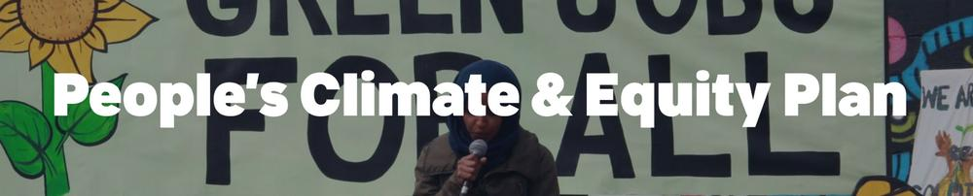
Mpls Climate Equity Plan Conversation with Council Member Jason Chavez
Sunday February 26 10am to 11am & on Zoom at Holy Trinity Lutheran Church
Learn how to get involved with supporting our City Council to pass, fund and launch implementation of our city's updated Minneapolis Climate Equity Plan. The Council will vote to approve the plan in May, 2023
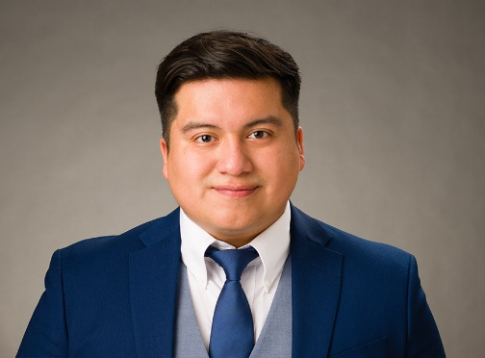 | 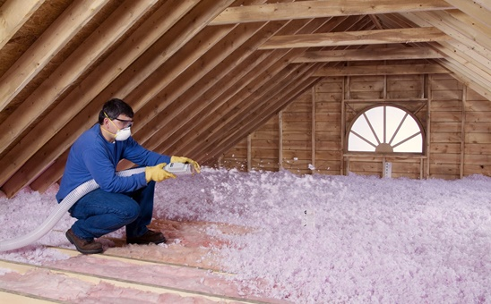 | 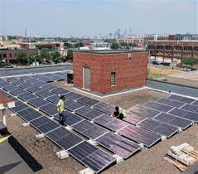
- Jason Chavez, 9th Ward Council Member 612 250-0489 jason.chavez@minneapolismn.gov
Sign up for 9th Ward Updates www.minneapolismn.gov/government/city-council/ward-9/newsletters/
Learn about the City of Minneapolis Climate Equity Plan Update sustainbility@minneapolismn.gov https://www2.minneapolismn.gov/government/programs-initiatives/climate-equity/
- Forum Handouts https://rccmn.co/minneapolis/ Sean Gosiewski, RCC, 612 250-0389 sean@rccmn.co

THE CITY OF MINNEAPOLIS HAS A GOAL TO
ACHIEVE NET-ZERO CARBON EMISSIONS* AND IMPROVE THE DAILY LIVES OF RESIDENTS, PARTICULARLY THOSE MOST IMPACTED BY OUR CHANGING CLIMATE.

Minneapolis Community-wide Carbon Emissions
* WHAT ARE CARBON EMISSIONS?
carbon emissions trap heat in our atmosphere and are mostly caused by heating, cooling, and lighting our
buildings, appliances, driving, cleaning our water, and disposing of solid waste
GHG Emissions (mt CO2e)
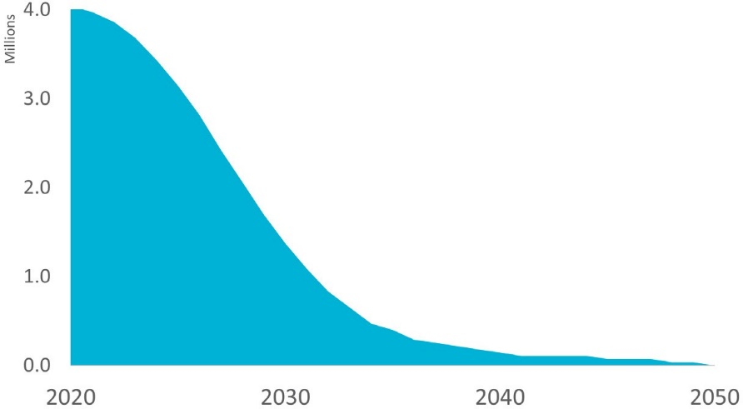

CARBON BUDGET

City/Community working groups developed draft goals & strategies

RESIDENTIAL (1-4 UNITS) | COMMERCIAL/ MULTIFAMILY | INDUSTRIAL |ENERGY SYSTEMS

GREENSPACE | WATER | TRANSPORTATION (COMPLETE COMMUNITIES) |

CIRCULAR ECONOMY (WASTE & FOOD) | SPECIAL TOPICS – Air Quality, Workforce, etc.

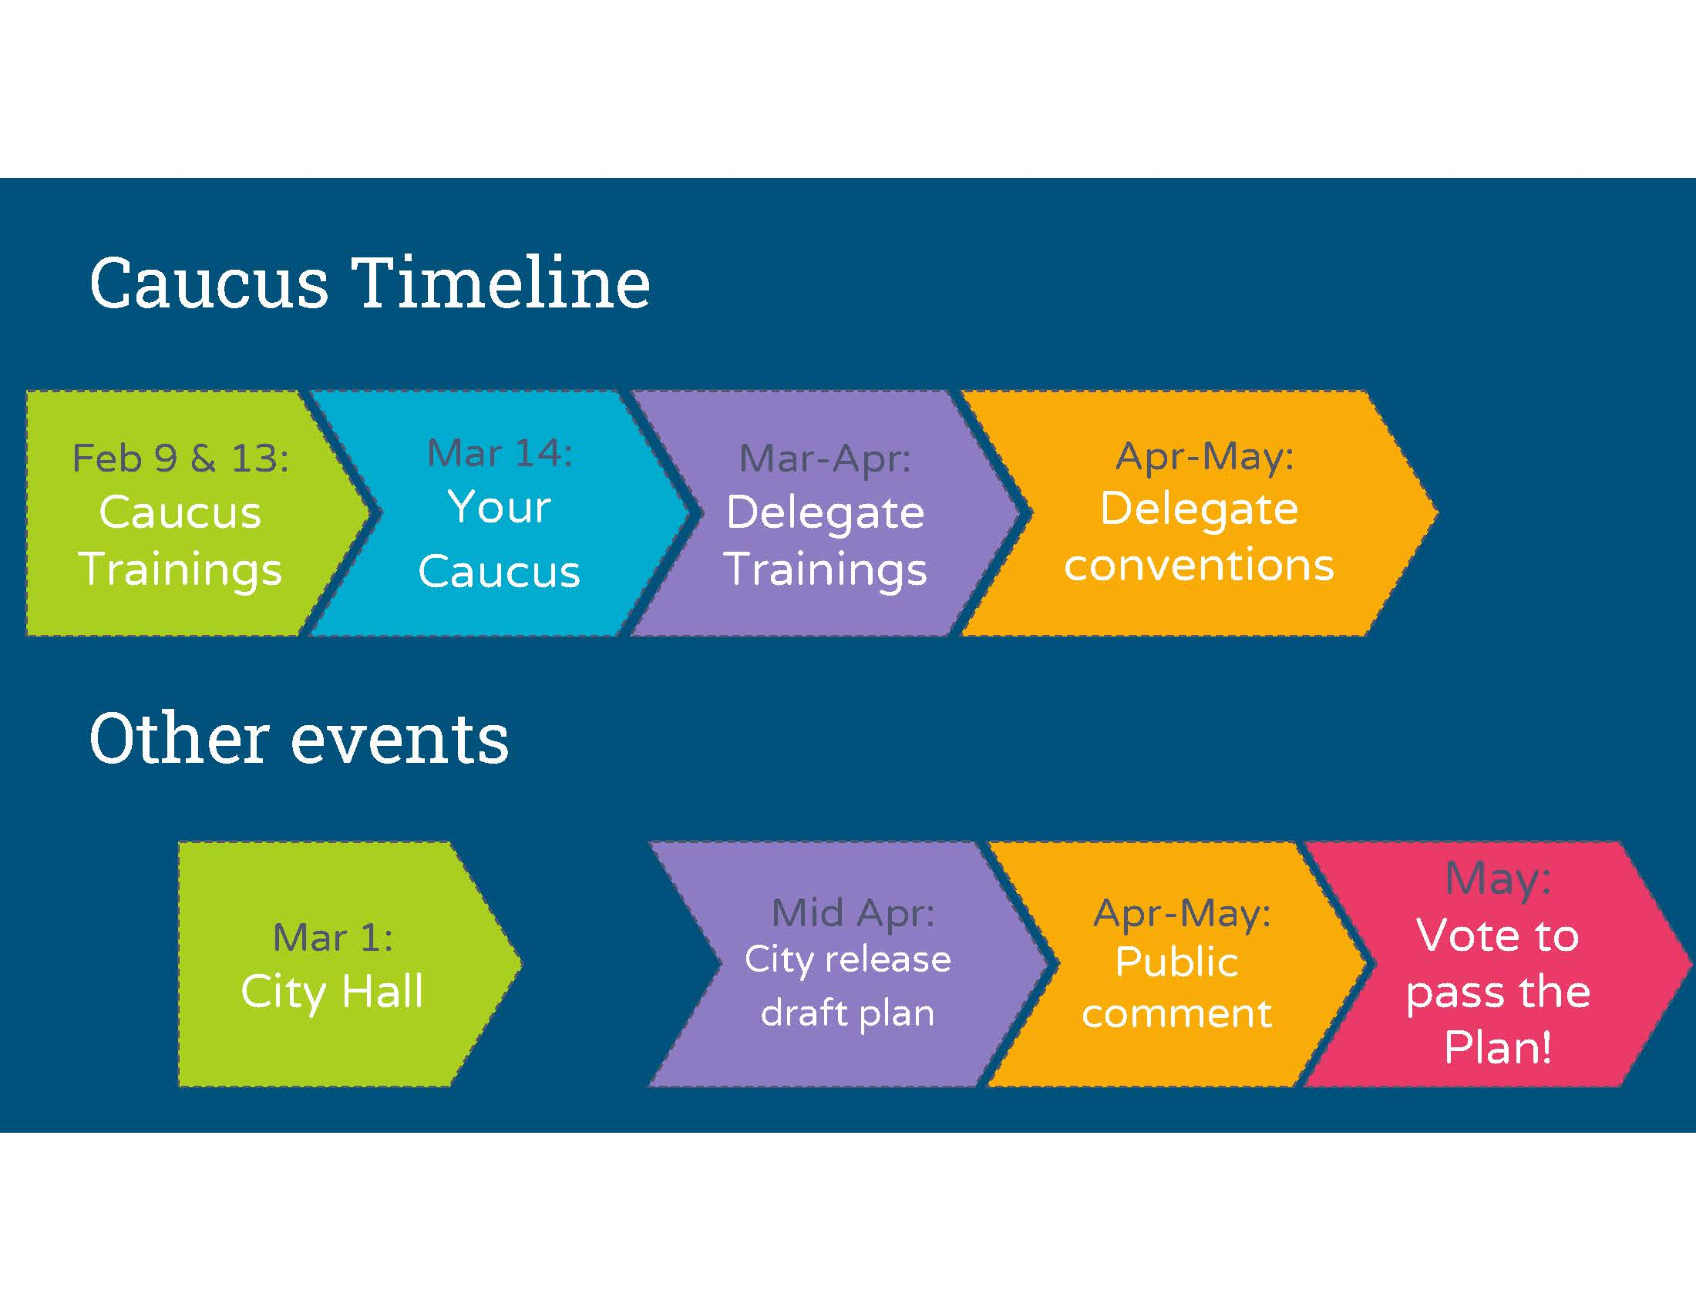
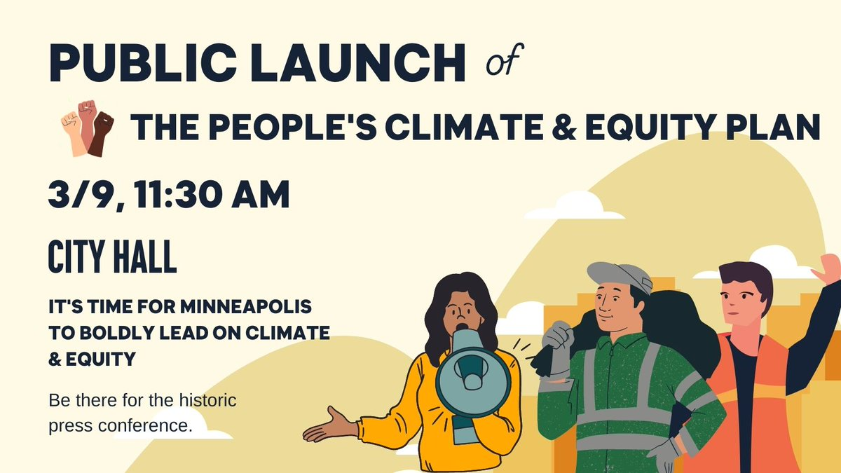 |  | Minneapolis People’s Climate & Equity Public Launch at City Hall  Thurs March 9, 2023, 11:30am - 1:00pm at  Minneapolis City Hall, 350 S 5th Street,  MN350  Ulla Nissen (612) 787-7110 ulla@mn350.org  - 9 Ward Volunteer Team Bonnie Beckel 612 722-6373 beckelbonnie@gmail.com  - 12th Ward Volunteer Team Lee Samelson, 970-270-7280 leesamelson@gmail.com

Minneapolis People’s Climate & Equity Plan https://mn350.org/peoples-climate-and-equity-plan/
- Just Transition Fund Coalition Community Power, MN 350, MN EJ Table, MN Renewable Now, MN IPL, SEIU Local 26, Sierra Club Northstar Chapter, Take Action MN, Unidos
- You are invited to join your Ward’s Volunteer Team to support your City Council Member & our Mayor to fully fund plan the plan in 2023 and stay involved in 2024 to support implementation in your neighborhood.

East Phillips Neighborhood Improvement Association/
- Proposed Indoor Urban Farm at the roof depot site https://www.eastphillipsneighborhoodinstitute.org/

The robust funding package we are asking the City Council to pass
Current annual city investments  $3 million/year Utility Franchise Fee  - Green cost share, home energy audits  Plus grant funded  Healthy Homes, Mobility Hubs, Air Quality | Future Annual City Investment goal  $50 million per year  - Utility Franchise Fee  - Pollution Control Annual Registration Fee (PCAR)  Plus Federal IIJA and State Matching Funds , Green Bank,

