Prioritizing Municipal Actions to Mitigate and Adapt to Climate Change: An Overview
Michael Orange, 12/28/22

Introduction, Purpose, and Audience

This is a high-altitude prioritization of the actions a Minnesota city should take to mitigate and adapt to climate change. Many cities have been taking these steps for years, even decades. Others have yet to begin.

Even though, for nearly a half century, the world has known about the existential crisis posed by climate change and the importance of the three “E’s” of sustainability (Environment, Energy, and Equity), few national actions have had substantive effects. After describing the most current list of climate change threats, Roy Stanton, the director of the Environmental Humanities Initiative at Notre Dame University, stated, “[W]e need to face the fact that the world we live in is changing into something else, and that coping with the consequences of global warming demands immediate, widespread, radical action.” ,

"This is all wrong. I shouldn't be up here. I should be back in school on the other side of the ocean. Yet you all come to us young people for hope. How dare you! You have stolen my dreams and my childhood with your empty words. And yet I'm one of the lucky ones. People are suffering. People are dying. Entire ecosystems are collapsing. We are in the beginning of a mass extinction, and all you can talk about is money and fairy tales of eternal economic growth. How dare you!”

Statement by climate activist, Greta Thunberg, 16, at the United Nations Climate Action Summit in New Your City, 9/23/19.

An article by Michael Noble and Aimee Witteman argues that Minnesota should adopt more ambitious policies to address climate change:

“Gov. Tim Walz’s plan targeting 100 percent clean electricity by 2040 would help tackle climate change’s growing threat and accelerate our COVID-19 economic recovery. ... But new research and the state’s latest greenhouse gas inventory shows that ... we must be even bolder on climate action. A carbon-free electric grid is a critical but insufficient step… As long-time advocates for climate justice, we see Minnesota’s incredible opportunity to be America’s climate policy North Star by demonstrating smart climate policy that delivers lasting payoffs — a strong economy, good-paying jobs, and healthier communities. And new polling shows a majority of Minnesotans support ambitious climate action, specifically a national 100 percent clean electricity standard by 2035.”

Since most people live in cities, and cities have the greatest potential to make an impact, the municipal level has the greatest potential for progress. We know what needs to be done, we know that it needs to be done yesterday, and we know how to do it and how to pay for it. The only real barrier is commitment. Every city needs a green champion; an individual or a group that inspires the city’s decision-makers (city council, planning commission, city manager, planning director, public works director, etc.) to move away from a status-quo mindset of “this is how we’ve done it in the past, so it’s good enough for the present” towards an openness to start down the path paved by other cities that are already well down on the following list of accomplishments.

Hopefully, this summary can offer encouragement and direction for a city’s green champion. Virtually every action a city takes to save energy and become more resilient and adaptable to climate change will also save money for the city and its residents. It just makes sense/cents!

Here are the most crucial steps

B3 Program: It is essential that the city’s focus begins with getting its own house in order first to serve as an example for others. The state’s Buildings, Benchmarks and Beyond (B3) Program is a free and essential first step. The B3 tools and programs are designed to make public buildings more energy efficient and sustainable. The B3 Guidelines and the SB 2030 Energy Standard can be applied to new and renovated buildings during the design phase. B3 Benchmarking, B3 Energy Efficient Operations, and the B3 Post Occupancy Evaluation programs can be used to evaluate and improve existing buildings.

While annual data entry can be accomplished by a person with little training, it is essential that facility managers use the program results to identify energy consumption anomalies and compare individual facility efficiencies with the benchmark data from the program’s inventories of similar facilities. Evaluation of the data and benchmark comparisons may indicate the need for a recommissioning of a facility, for example. Attachment 1 includes a screen shot that offers a glimpse of the graphical and analytical power of this free program.

GreenStep Cities: The next step for any city is to join the GreenStep Cities Program. Officially launched in 2010, the Program, which is managed by the Minnesota Pollution Control Agency through a public-private partnership, has helped nearly 150 cities address these challenges by providing a convenient clearinghouse of information that is targeted to all Minnesota cities. This free, continuous improvement program offers an encyclopedic collection of best practices, links to state-of-the-art articles and free expert consultants, and constantly updated progress reports from participating cities. It is a voluntary, action-oriented program that supports and salutes the implementation of best practices that help cities identify and achieve sustainability and quality-of-life goals, and adapt to our rapidly changing climate. Attachment 2 has a screen shot that summarizes the benefits of the program. See also the Gold Leaf climate action program that provides a pathway for taking 44 high-priority, high-impact, climate actions.

Greenhouse gas assessments: As described by Osborne and Gaebler in their book, Reinventing Government (1992), “If you don’t measure results, you can’t tell success from failure. If you cannot see success, you cannot reward it. If you can’t see failure, you can’t correct it.” Greenhouse gas (GHG) emissions serve as a common denominator for the comparison of kilowatts, natural gas therms, and gallons of vehicular fuels consumed; vehicle and air miles traveled; tons of municipal solid waste processed; gallons of sanitary sewage treated; and gallons of potable water produced. GHG emissions offer a unique way to compare the effectiveness of various energy and sustainability choices and their related costs.

Greenhouse gas assessments have two major components: A citywide assessment accounts for the GHG emissions associated with activities within the entire border of the city (energy consumption by all residences and commercial/industrial/institutional buildings, transportation, solid waste management, wastewater treatment, etc.). Attachment 3 includes a graphic that illustrates total GHG emissions for the City of Edina. The other component, the city operations assessment, focuses on the emissions associated with city-owned and leased buildings and facilities, city fleets and official travel, and waste management. It’s a subset of the citywide assessment.

- City operations GHG assessment: Every city prepares annual operating and capital improvement budgets. A city operations GHG assessment is akin to the environmental budget for the city. Of the two kinds of assessments, a city will have the most ability to improve its city operations assessment. Attachment 4 includes a page from the City of Burnsville City Operations Greenhouse Gas Assessment, 2005 to 2021. This assessment will:

- Enable the city to serve as a good example. A city can’t legitimately ask its community to increase energy efficiency and climate adaptability if it is unwilling to lead the way and track progress towards specific goals.
- Highlight opportunities to reduce emissions, and save resources and money. A city has limited ability to move the needle on communitywide emissions and adaptability but strong operational control over its own facilities.
- Provide baselines for estimating the effectiveness of many sustainability measures.
- Enable comparison with future inventories and peer cities.
- Inform subsequent analyses, plans, and policy decisions.
- Improve the city’s competitiveness for federal and state funding opportunities that are targeted to cities that have taken steps to measure and improve their energy efficiency and reduce their carbon footprints.
- Assist in promoting public understanding of the city’s effects on climate change.
- Serve as a model for other cities.

Experience with prior city operations assessments indicates that important benefits often result from the preparation process as well. It can spark common interest among the involved city staff in understanding why energy consumption fluctuates from year to year, it can encourage the sharing of ideas among different departments, and it can foster a common desire to reduce emissions.

The assessments for the City of Burnsville offer a lesson on the importance of the city operations assessment and potable water. In the 2005 base year for the assessment, the production and distribution of water constituted more than half of Burnsville’s overall city operations footprint of GHG emissions. Over the next 16 years, the city invested about $19 million in improvements to the system. The city operations assessment for 2021 showed that the same amount of energy produced 67% more water in 2021 than in 2005 due primarily to these investments. This was the dominant factor that enabled the city to reach and exceed its 2025 citywide, GHG reduction goal 4 years earlier with its 34% GHG reduction from the 2005 base year. From the assessment: “Over the 17-year Study Period, the City’s annual GHG reductions below the 2005 Base Year’s emissions totaled about 51,000 tonnes, about 3,000 tonnes per year on average. This would offset the equivalent annual emissions from nearly 1,600 households over the Study Period, or about 89 households on average each year.” These kinds of summary metrics are very valuable for promoting a city’s efforts and successes towards improved sustainability.

See additional examples of city operations GHG reduction goals and inventories on the MN Sustainability Index.

- Citywide GHG assessment and reduction goals: The primary document that guides a city’s future is its comprehensive plan. Many cities’ comprehensive plans now include a chapter on sustainability or have sustainability measures integrated throughout it. However, this is not sufficient to address the existential threat of climate change. The tool cities need to be fully prepared is called a climate action plan (described below).

A key element of a climate action plan is the development and formal adoption by the city of challenging but reasonable GHG reduction goals. The accomplishment of these goals can guide the subsequent implementation of components in the climate action plan. Of course, goal setting begins with measurement. It’s the citywide GHG assessment that provides the historic citywide GHG emissions data needed to generate the goals.

See additional examples of community-wide GHG reduction goals and inventories on the MN Sustainability Index.

- Study years and updates: The citywide and city operations assessments should include 3 or more study years to get to the current calendar year. If the city has already made significant progress with projects that reduce greenhouse gas emissions (e.g., widespread LED bulb replacements, building recommissionings, etc.), the base study year should be set prior to those improvements so the reduction goal can be more reasonable. For example, assuming the major improvement projects began in 2012, the assessments could set 2011 as the Base Study Year, then include 2013, 2016, 2019, and 2022 as additional Study Years. Using a separate RFP process, the city should commit to updating the citywide assessment every 4-5 years and the city operations assessment every other year, minimally.

Climate action plan: Climate action plans can vary significantly depending on the amount of community engagement, the desired project schedule (e.g., shorter can be more expensive), and on the plan’s components. Possible components include the following:

- Citywide and city operations GHG reduction projections (e.g., business as usual, best case, and most reasonable case projections out 10 or more years), and mid and long-range goals and implementation actions based on the respective GHG assessments and projections
- Sustainability indicators and communication tools (e.g., a sustainability progress dashboard for the city’s website)
- Climate vulnerability and adaptation goals and implementation actions
- Renewable energy goals and actions
- Community wide tree and ground cover goals and actions
- Carbon sequestration planning
- Climate emergency and disaster planning

Attachment 5 includes excerpts from the Edina Climate Action Plan. Also see examples of climate action plans on the MN Sustainability Index.

Costs: Costs will vary markedly based on the scope of a study and the size and complexity of a city. It’s very important to include extensive community engagement in the planning process, which can also affect costs. Studies for cities that rely on regional systems for electricity, solid waste management, potable water, and wastewater treatment will be much easier to produce than for cities that actually provide these same essential services. As such, the following cost ranges are wide to account for these significant variables while still providing a general sense of scale for a city’s decisionmakers. A city will need to go through a request for proposal process to establish actual costs:

- B3 program and GreenStep Cities programs: Free
- Custom citywide GHG assessment: $8,000-$12,000
  - Updates to a citywide assessment (every 3-5 years): $2,000-$4,000
  - Basic: Available for cities included in the Regional Indicators Initiative and/or Twin Cities Greenhouse Gas Inventory: Free
- Custom city operations GHG assessment: $6,000-$10,000
  - Updates to a city operations assessment (every other year): $3,000-$7,000
  - Basic: Available through the GreenStep Cities program’s Step 4 & 5 metric reporting tool: Free
- Climate action plan (CAP): $30,000-$70,000. See the City of Red Wing’s Climate Action Work Plan for an example of a CAP-light. Total cost: $15,000 (2021)

Attachments:
- Screen shot from the State’s Buildings, Benchmarks and Beyond program
- Screen shot from the State’s GreenStep Cities program
- Graphic from a citywide GHG assessment: Excerpt from the Edina Climate Action Plan
- Graphic from a city operations GHG assessment: Excerpt from the City of Burnsville City Operations Greenhouse Gas Assessment, 2005 to 2021
- Excerpts from the Edina Climate Action Plan

Attachment 1

Screen Shot from the State’s Buildings, Benchmarks and Beyond Program
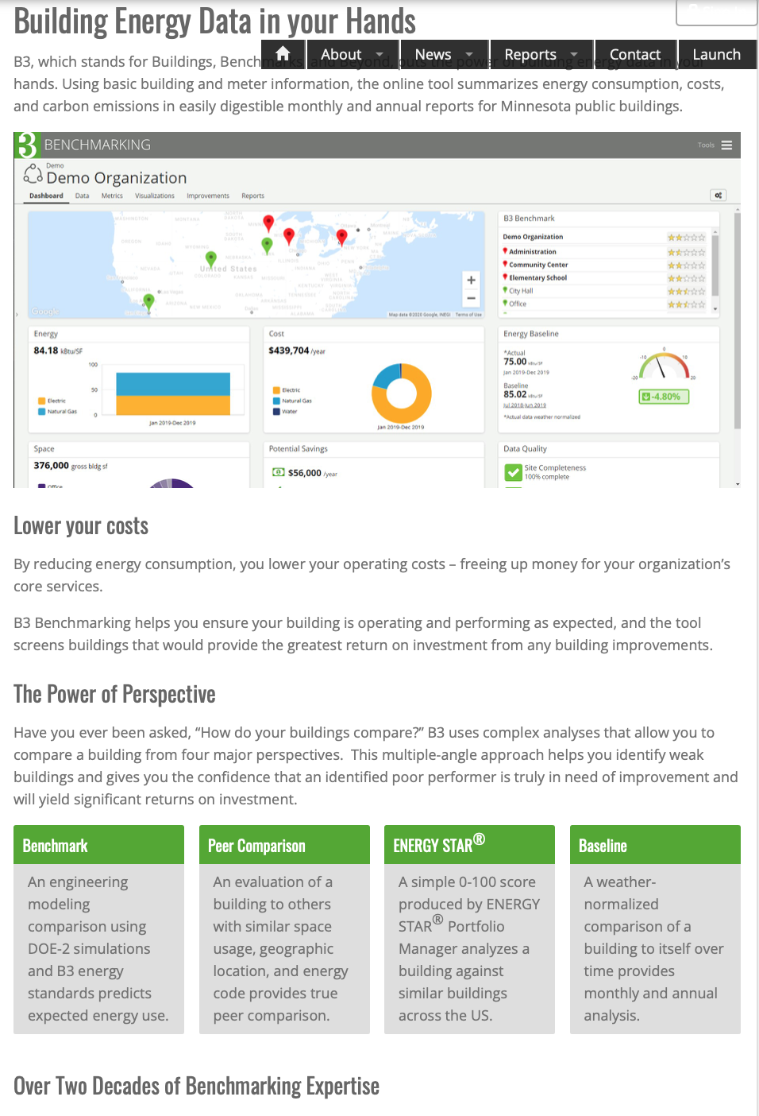

Attachment 2

Screen Shot from the State’s GreenStep Cities Program

Attachment 3

Graphic from a Citywide Greenhouse Gas Assessment: Excerpt from the Edina Climate Action Plan

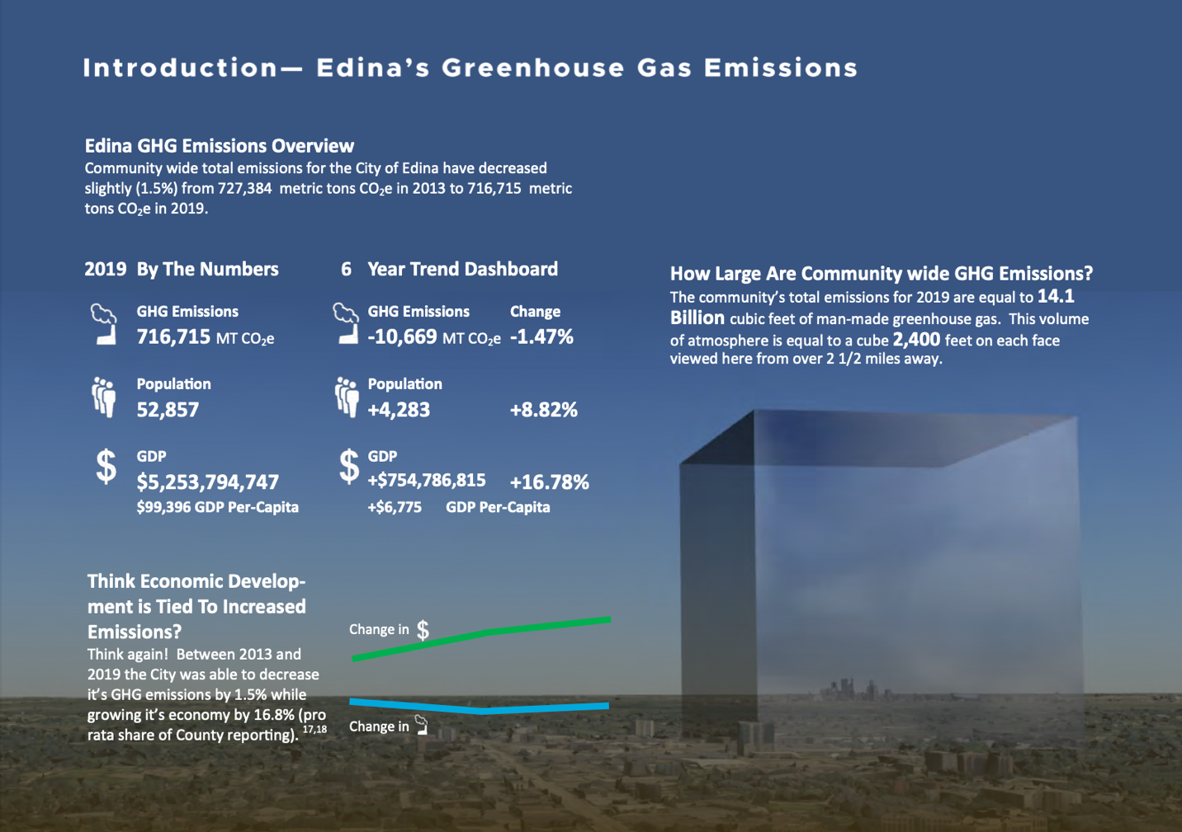

Attachment 4

Graphic from a City Operations Greenhouse Gas Assessment: Excerpt from the City of Burnsville City Operations Greenhouse Gas Assessment, 2005 to 2021

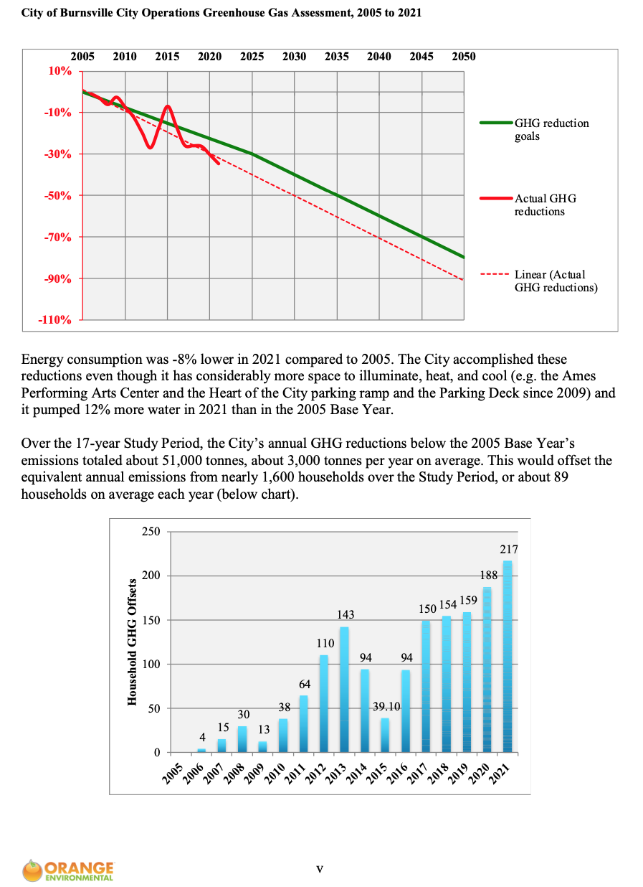

Attachment 5

Excerpts from the Edina Climate Action Plan

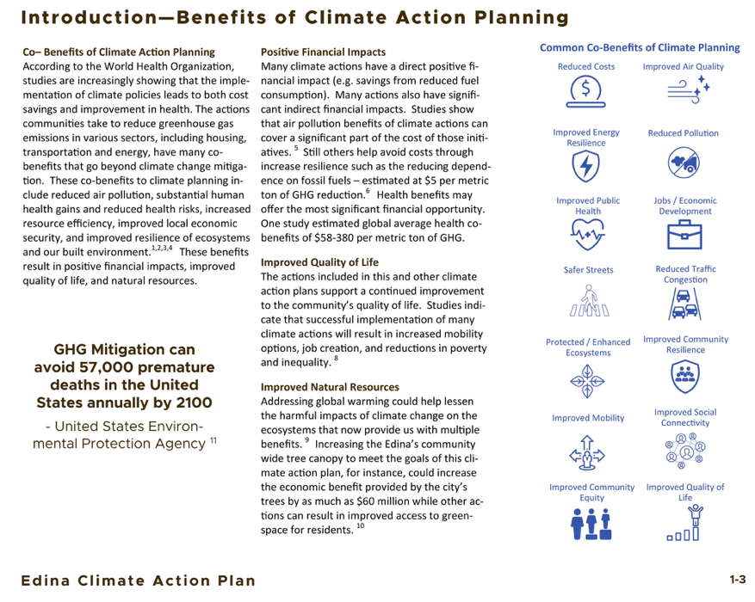

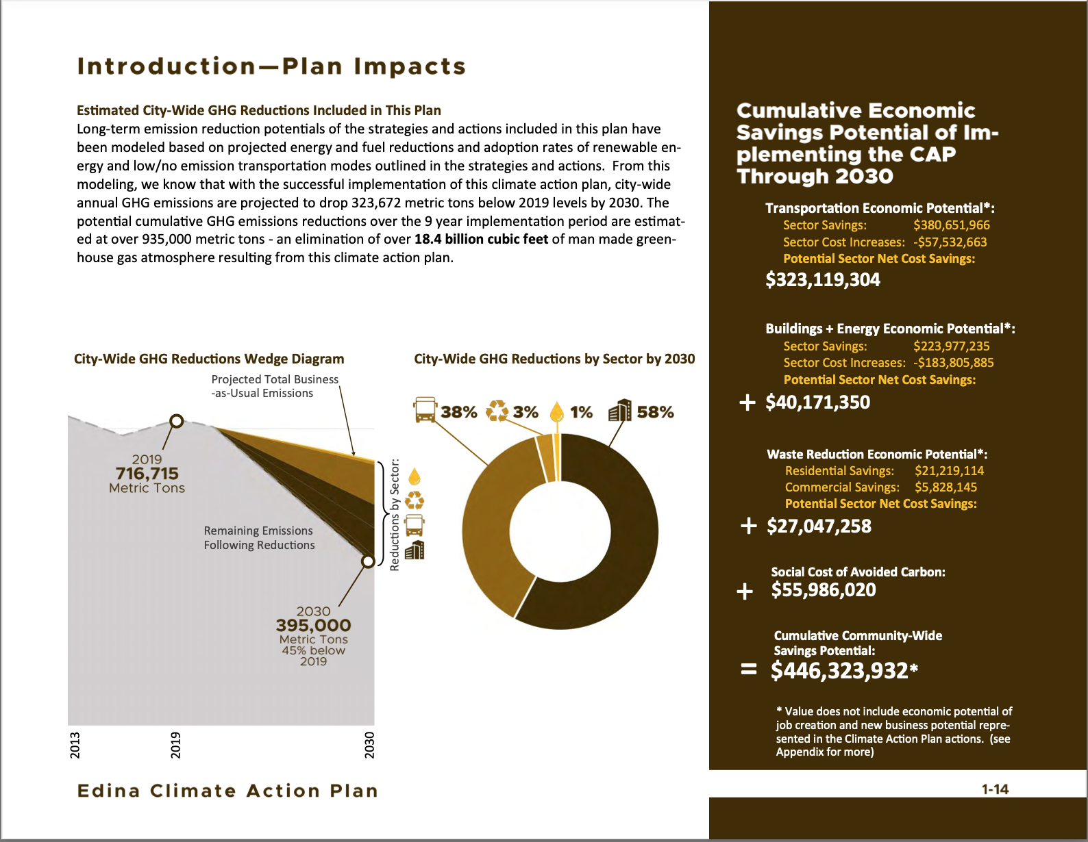

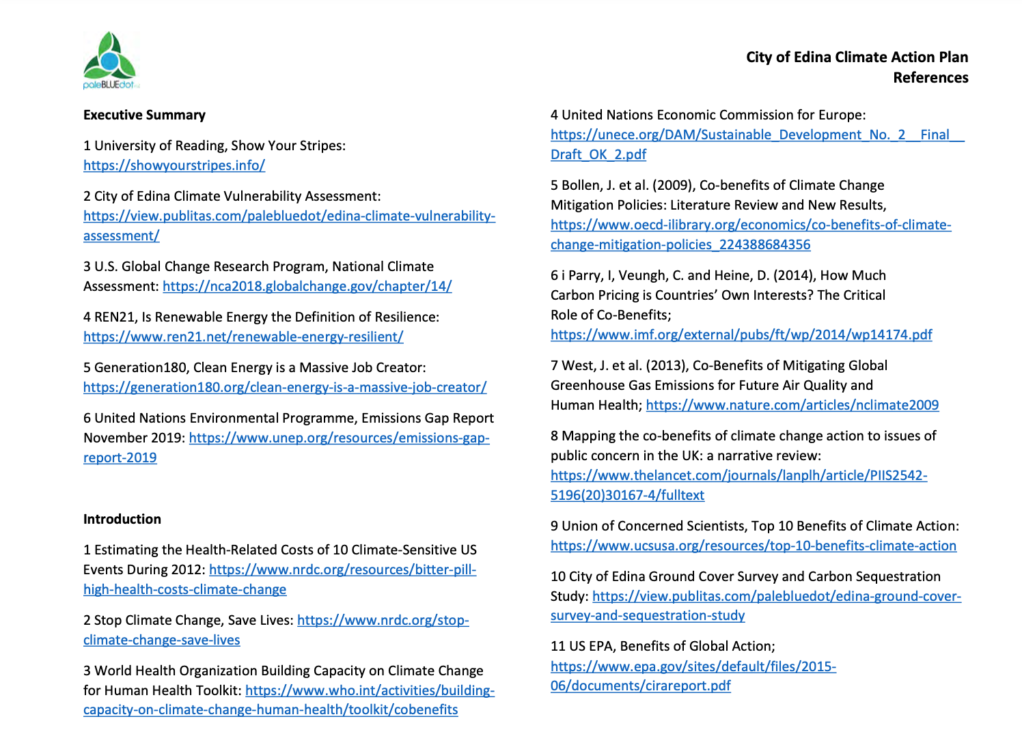

I’ve Said Goodbye to Normal. You Should, Too, Roy Scranton, New York Times, 1/25/21
See also the United Nations NDC Synthesis Report, 2/26/21
Source: https://www.npr.org/2019/09/23/763452863/transcript-greta-thunbergs-speech-at-the-u-n-climate-action-summit
“Boldness required: Minnesota should adopt more ambitious climate policies Fortunately, climate solutions generate massive benefits,” Michael Noble and Aimee Witteman, Minnpost, 2/17/21.
For example, cities in the metropolitan area can access from the Metropolitan Council community data including GHG emissions data regarding transportation-related emissions, and a city’s share of regional emissions from wastewater treatment. Xcel Energy provides energy consumption (electricity and natural gas) and GHG emissions data for cities within its service area.

