Sample Agenda - fall 2022 City/County Climate Action Check In Events
http://rccmn.co/city-county-climate-action-check-in-events/
Contact Sean Gosiewski, RCC, 612 250-0389 sean@rccmn.co to sign up to attend &/or to join an event planning team
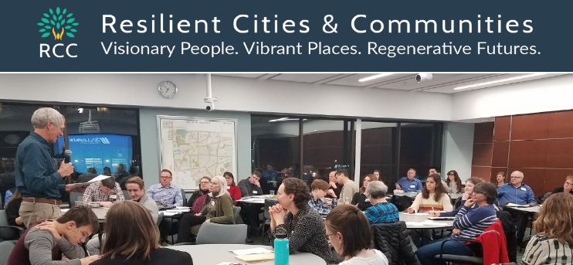  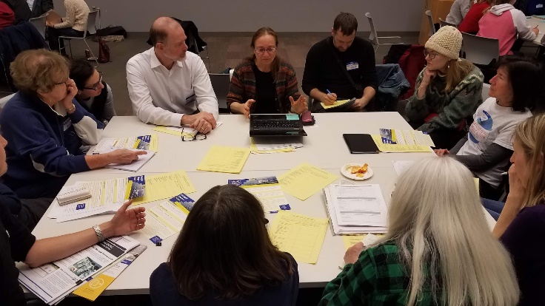 | Annual Fall City/County Climate Action Check In Events  Goal - maintain mutual accountability & transparency during implementation to stay on track to meet their 2030 & 2050 city and county climate, sustainability, equity, natural resources and zero waste & other comprehensive plan goals on time  Who - Interested Cities with climate &/or sustainability goals (city staff, commissions, elected leaders) meeting with interested County Leaders (Commissioners, Dept. staff) partners (Met Council, Watersheds, Utilities, businesses)  When - Fall 2022 and annually from 2022 through 2030  How - Each County Cluster will have a planning team that will  - Plan their event agenda, choose topics to cover and speakers (Topic Teams can help)  - Schedule their hybrid event (in person & on line)  - Secure space & needed resources, & invite speakers  - Invite city, & county staff, commissions, elected leaders, partner groups and interested residents, citizen coalitions and community groups.
Sample Agenda - Fall 2022 City/County Climate Action Check In Events (half day)
Pre-event - participating cities and county department will send in short summaries of the actions they have taken and plan or hope to take in the future, related to achieve their 2040, climate, resilience &/or sustainability goals
Plenary
- Welcome and County update from leaders
- City updates - city representatives will share short highlights of actions their city has taken and are planning
- How are we doing? - Update to science-based GHG targets, carbon budget & timeline to meet 1.5 degree goal
- County, Met Council and/or Regional Indicator staff will share recent GHG data & climate impacts by sector - clean energy, buildings, transportation, natural resources, waste management, (green jobs, health, housing)
- Panel Presentation on current highlights of trends/innovation & high impact opportunities for city, county & MN (mitigation, adaptation, equity) energy, buildings, transportation/pipes, natural resources, zero waste, jobs
Topic Break Out Conversations - with topic resource people and city, county and community representatives
Clean Energy - grid scale and local solar | Commercial & Residential Buildings | Transportation EVs, transit, VMT, bike ped | Adaptation - H20, natural resources, sequestration, trees | Additional topics - zero waste, green jobs, etc.
- Review relevant GHG emissions data & current trends/innovation & high impact action opportunities
- Report on city & county actions taken during the year
- Plan next steps using the Met Council’s new Climate Action Scenario Planning Tool
- Identify resources cities and county departments will need to take these steps
- Brainstorm ways to secure the resources - forming new topic-specific multi-city implementation teams, applying together for competitive state or federal funds, needed state policy changes.
Plenary
- Topic Groups will share highlights of their priority actions, barriers, new resources and next steps
Small Groups - City Teams will meet to share the actions they are inspired to do and plan next steps to advance them

