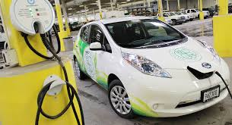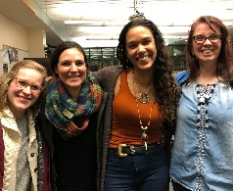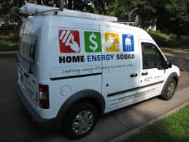
Notes & Next Steps West Metro Cities Climate Action Conversation
St. Louis Park City Hall (Council Chambers) 5005 Minnetonka Blvd, St Louis Park, MN 55416
Co-Hosted by the St. Louis Park Environment and Sustainability Commission and Resilient Cities and Communities. www.rccmn.co/hennepin-communities
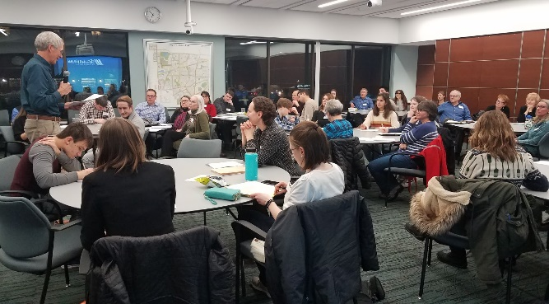 | 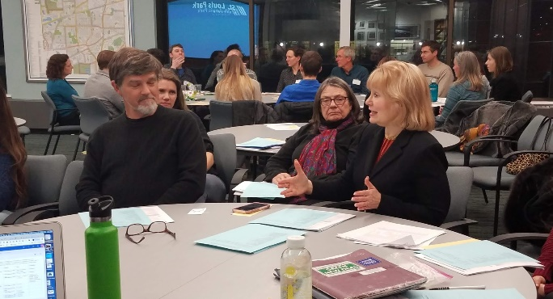
Priority actions (pages 2 to 4) participants were interested Participant list (pages 5 to 6)
6:00 p.m. Student Commissioners, High School Environmental Club leader gathering
6:30 p.m. Welcome from Council Member Larry Kraft, City of St. Louis Park
Brief updates from Cities on their 2020 Environmental Commission work plans
7:00 p.m. Small Group Conversations to review high impact actions our cities can take to achieve our GHG reduction goals, and brainstorm ways our cities can work together.
- Clean Energy Supply (High Impact Actions) Erin Niehoff & Stacy Miller - Mpls, Dan Katzenberger - Eden Prairie with Nicki Nicole Ciulla, St. Louis Park
- Efficient Buildings (High Impact Actions) Tim Sandry - Bloomington, Leah Hiniker - Hennepin County with John Dunlop, Minneapolis,
- Transportation (High Impact Actions) Jennifer Munt - Mtka, Brian Ross, GPI,
8:00 p.m. Planning Our Next Steps – Share small group insights. Plan ways to stay in touch.
8:30 p.m. Networking - New environmental commissions can meet experienced commissions
- Hennepin County Developing a Climate Resiliency and Adaptation Plan (handout)
For questions contact:
Sean Gosiewski, Director,
Resilient Cities and Communities
612-250-0389 | Sean@rccmn.co
www.rccmn.co/hennepin-communities

A SPECIAL THANKS TO OUR SUPPORTERS
Lenfestey Family Foundation

High Impact Actions for Low Carbon Cities
Jan 22 West Metro Cities Climate Action Conversation (@ SLP Council Chambers)
Notes on high-impact city & county actions cities wanted to learn about & potentially collaborate on Resilient Cities and Communities Coalition www.rccmn.co/hennepin-communities
Sean Gosiewski, Director, Resilient Cities and Communities 612-250-0389 sean@rccmn.co
Additional Resources – USDN High Impact Actions MN GreenSteps High-Impact Sample Policies
Low Carbon Transportation/Land Use (High Impact Actions) Resource Handout
Priorities from the Small Group Conversation and Surveys
Priority 1. Chloride Reduction - Reduce winter salt use on roads, parking lots and sidewalks through cities & Hennepin County
- Learn more (9) Potentially collaborate with other cities (5)
- Supporting the MN legislature to pass the Stop Over-salting bill to reduce liability for trained private contractors that document their steps http://stopoversalting.org/
- Work with Cargill to promote use of their new innovative products with cities and counties https://www.cargill.com/industrial/winter-road-maintenance/clearlane-enhanced-deicer

Priority 2. Plan for successful & equitable in-fill redevelopment - Net Zero, Equitable, Walkable, TOD
- Learn more (11) Potentially collaborate with other cities (2)
- Plan for successful & equitable in-fill redevelopment – Hennepin County convening cities that are planning for, updating their zoning and ordinances and recruiting private developers to talk about how they can enable through zoning ordinance changes, up-zoning, sustainable building policies, affordable housing zoning overlays, advanced building methods and innovative financing (PACE, corridor wide TIF)
- Inclusive, Affordable, Mixed use Transit Oriented Development
- Net Zero/ Sustainable/ SB 2030 Building Construction (lower energy costs)
- Transit, bike, walk accessible with shared mobility options (reduce transportation costs)
- Brooklyn Center is looking for assistance on this for their re-development of 22 acres and the old Brookdale Shopping Center
Priority 3. Support sustained state, regional & county transit investments. Reprioritize spending.
- Learn more (8) Potentially collaborate with other cities (4)
- Protect Hennepin County Transit Investment Funds - Maintain and plan for transit investment in future BRT and LRT lines from the .25% sales tax increase for transit (MPR Story)
- Ask Hennepin Co. Commissioners to vote no on March 19 to re-allocating some county transit funds (future Bottineau line) to road expansion on Plymouth Ave (Star Tribune Story)
- Likely that Mayor Hoveland from Edina would sign on to a letter making this request
- Enable free fairs on metro transit busses, BRT and LRT through increased transit investment
- Last mile connection resources for SWLRT (Minnetonka)
Priority 4. Prioritize pedestrians, bikes, transit in public right of ways complete streets, reconstruction
- Learn more (6) Potentially collaborate with other cities (4)
- City and Hennepin County Pedestrian, Bike and Trail Plans, Active Living Hennepin Communities
- Edina will continue implementing their Living Streets plans – sidewalks, trails, etc.
Action 5. Support increased adoption of Electric Vehicles - City Fleets, E.V. Charging Ordinance
- Learn more (2) Potentially collaborate with other cities (6)
- GPI – Cities Charging Ahead, (communities tab) www.driveelectricmn.org/cities-charging-ahead/ MN DOT/MPCA and Xcel Energy
- Support $8 million request for legislature to electrify Metro Transit Busses
Action 6. Shared Mobility - joint powers agreement between cities to regulate shared mobility
- Learn more (7) Potentially collaborate with other cities (4)
- Contact the Twin Cities Shared Mobility Collaborative https://www.tcsharedmobility.org/about
Action 6. Quantify GHG emissions from Transportation & Prioritize High Impact Actions cities can take
- Learn more (4) Potentially collaborate with other cities (2)
- Current Met Council Project – with resources to be announced soon
- Mauricio León, Metropolitan Council Senior Researcher, Regional Indicators 651 602-1146 mauricio.leon@metc.state.mn.us in 2020 and 2021, the Met Council will add Metro Climate Stats and a Scenario Planning tools to the Energy and resilience planning resources provided to cities during comp planning https://metrocouncil.org/Handbook/Plan-Elements/Resilience.aspx
- Metro cities will receive their community wide GHG data in mid-2020 from the Met Council (electricity, natural gas, VMT, water use, solid waste, etc.) https://metrocouncil.org/Council-Meetings/Committees/Committee-of-the-Whole/2019/05-01-19/Creating-tools-for-Climate-Change-PPT.aspx
- Sample Strategy Lists/ VMT Reduction Scenario Planning Tools for metro cities - coming in 2021 from Met Council and Center Healthy Sustainable Cities www.sustainablehealthycities.org/
Efficient/ High Performance Buildings (High Impact Actions) Resource Handout
Priorities from the Small Group Conversation and Surveys
Priority 1. Adopt an Energy Benchmarking Ordinance
- Learn more (9) Potentially collaborate with other cities (9)
- Hennepin Co. Efficient Buildings Collaborative with Minneapolis, Edina, SLP (more cities welcome! www.hennepin.us/your-government/projects-initiatives/efficient-buildings-collaborative
- Leah Hiniker, Energy Manager, Hennepin County 612-543-1219 leah.hiniker@hennepin.us
Priority 2. Adopt a Sustainable Building Policy - high performance construction with city investment
- Learn more (9) Potentially collaborate with other cities (9)
- City of Minneapolis – Sustainable Building Policy is being developed in 2020 building upon St. Paul’s policy while adding specific requirements for City Buildings , Commercial, Multi-family – private and nonprofit Single Family Contact: Luke Hollenlamp 673-2349 luke.hollenkamp@minneapolismn.gov
- City of St. Paul – Sustainable Building Policies Kurt Schultz, 651 266-6590 kurt.schultz@ci.stpaul.mn.us
Priority 3. Support Legislation or Statewide Policy Improvements for better new construction
- Learn more (10) Potentially collaborate with other cities (8)
- Option 1 - New Legislation - Optional Advanced Performance Building Standard MN Cities Can Adopt – https://www.pca.state.mn.us/sites/default/files/tdr-fg15-01.pdf
- Option 2 - Update Statewide Building Energy Code sooner www.energycodes.gov/adoption/states/minnesota
- Brian Hoffman, SLP, Building and Energy Director: 952.924.2584 bhoffman@stlouispark.org
- Stacy Miller, Energy Policy, City of Minneapolis 612 673-3110 stacy.miller@minneapolismn.gov
Priority 4. New Buildings - Educating Developers Xcel design assistance, PACE $ for Construction
- Learn more (7) Potentially collaborate with other cities (8)
- St. Paul Port Authority – energy efficient & Net Zero commercial building construction and PACE Financing for New Construction for better building envelopes and HVAC www.sppa.com
- MN ULI – Re-Development Ready Guide Xcel – Energy Design Assistance (EDA)
- Trillion BTU Fund www.sppa.com/energy-financing/trillion-btu Require building for assessed need
- Edina Updated Policy on New Multifamily Housing Steph Hawkinson 952-833-9578 shawkinson@edinamn.gov
Priority 6. Comment at the MN PUC & Legislature to improve low income access to Utility Conservation Improvement Programs (CIP) Learn more (5) Potentially collaborate with other cities (5 )
Priority 7. Truth in Sale of Housing Inspections (adding an energy audit & energy score) Learn more (1)
Priority 8. Combine multi-family Energy Improvements with 4d Affordable Housing Tax Incentives. Did not have time to discuss this one on Jan 22

Clean Energy Supply - (High Impact Actions) Resource Handout
Priorities the Small Group Conversation and Surveys
Priority 1. Procuring Renewable Energy for City Operations
- Learn more (10) Potentially collaborate with other cities (8)
- Community Solar Gardens – https://www.cleanenergyresourceteams.org/solargardens
- Solar Possible - www.cleanenergyresourceteams.org/joint-procurement-solar-energy Peter Lindstrom MN CERTs, (612) 625-9634 plindstr@umn.edu
- Renewable Energy Procurement Cohort – CERTS, GPI Collaborative purchasing (Edina)
Priority 2. Expanding Rooftop Solar within City Businesses, Institutions (schools), Residents
- Learn more (15) Potentially collaborate with other cities (8)
- Adopt SolSmart policies & ordinances – link Cameran Bailey, SolSmart Met Council 651.602.1212 cameran.bailey@metc.state.mn.us
- Provide Solar Feasibility Studies to businesses & institutions with the best roof tops in your city Maplewood Case Study – Providing Solar feasibility studies for 50 businesses
- Solar bulk purchasing campaigns https://www.midwestrenew.org/solargroupbuy/
Priority 3. Cities Commenting on Xcel’s Integrated Resource Plan (IRP) in April, May, June –
- Learn more (8) Potentially collaborate with other cities (6)
- Purpose: Access community-wide clean power sooner. Retire coal faster, limit new natural gas plants, increase distributed generation and demand response
Next Steps – in April/May Stacy Miller and Tara Brown will offer several webinars to support additional cities to participate in contributing comments after Xcel provides their updated IRP in April
- Create a shared letter to the MN PUC and Xcel that cities can sign on to
- Minneapolis - Stacy Miller, Energy Policy 612 673-3110 stacy.miller@minneapolismn.gov
- Edina - Tara Brown Sustainability Coordinator, 952 826-1621 tbrown@edinamn.gov
- Xcel https://www.xcelenergy.com/company/rates_and_regulations/resource_plan_overview
- Fresh Energy https://fresh-energy.org/tag/xcel-energy/
Priority 3. Additional Cities Helping with City of Minneapolis 100% Renewable Energy Resolution
- Learn more (7) Potentially collaborate with other cities (6)
- Contact Stacy Miller, City of Minneapolis 612 673-3110 stacy.miller@minneapolismn.gov
- Example project (suggested by Dan K) Renewable Energy Contract of Google Data Hub in Becker, MN to buy power from large projects Mortenson Construction is developing
The resolution establishes renewable electricity definitions, priorities, progress metrics, and next steps. City staff have created a municipal operations report on expected future electricity consumption and a follow-up blueprint on paths toward 100% renewable electricity municipal operations. Read the City’s blueprint for achieving this goal. http://www.minneapolismn.gov/sustainability/buildings-energy/WCMSP-210721
Priority 4. Support Legislation (2021) to Continue Xcel Energy’s Solar Rewards
- Learn more (10) Potentially collaborate with other cities (5)
- This is important to maintain and expand incentives for rooftop PV solar (distributed generation)
- To enable cities to succeed in meeting their local renewable energy production goals
- Contact Stacy Miller, City of Minneapolis 612 673-3110 stacy.miller@minneapolismn.gov
Priority 5. Solar Ready Building Construction (City, businesses, multifamily) require wiring to roof, etc.
- Learn more (8) Potentially collaborate with other cities (5)
Priority 6. Support Legislation (2020 Centerpoint Energy) to advance renewable natural gas via PUC
- (Was not discussed on Jan 22) CenterPoint Energy Proposes Natural Gas Innovation Act seeks to reduce greenhouse gas emissions and advance Minnesota's clean energy future LINK for more info
- Al Swintek, Government Relations Centerpoint (612) 321-4799 albert.swintek@CenterPointEnergy.com
Participants
West Metro Cities Climate Action Conversation with Environmental Commissions Volunteers
Wednesday January 22, 6:30 pm to 8:30 pm at St. Louis Park City Hall www.rccmn.co/hennepin-communities
- Tim Sandry Bloomington Sustainability Commission Chair
- John Crampton Bloomington Sustainability Coalition IKES
- David Drummond Bloomington Sustainability Commission Commissioner
- Joseph Strommen Bloomington Sustainability Commission Commissioner
- Emma Struss City of Bloomington Sustainability Coordinator
- Jared Galligan Champlin ERC Chair
- Jeff Harken Chanhassen Env. Commis. Commissioner
- Greg Hawks Chanhassen Env. Commis. Commissioner
- Andrea Sit Chanhassen Community volunteer
- Rae Farley Eden Prairie, RCCC, West Metro Alliance Intern
- Daniel Katzenberger Eden Prairie, Conservation Commission, Energy/Carbon Team Lead
- Mindy Ahler Edina Transportation Commission Member
- Michelle Horan Edina Energy & Environment Commission Member
- Ana Martinez Edina Energy & Environment Commission Student Commissioner
- Chloe Maynor Edina High School Project Earth Club
- Chuck Prentice Edina Energy & Environment Commission EEC Outreach Committee
- Lauren Satterlee Edina Energy & Environment Commission Co-Chair
- Bill Sierks Edina Energy & Environment Commission Past Commissioner
- Paul Thompson Cool Planet, Citizens Climate Lobby EEC Outreach Committee
- Michelle Meek Community Volunteer Community Volunteer
- Molly Cummings Metropolitan Council Member District 5
- Joseph Ramlet Golden Valley Environmental Commission Student Commissioner (Hopkins H.S.)
- John Dunlop MN Renewable Energy Society Engineer
- Marianna Hefte Minneapolis CEAC Student Commissioner
- Stacy Miller City of Minneapolis Sustainability Program staff
- Erin Niehoff Minneapolis CEAC Chair
- Koral Purdy Bottineau Neighborhood Volunteer
- Kyle Samejima Mpls Climate Action Exec Dir.Kara Thate Minneapolis, Midtown Phillips
- Anthony Varriano Minneapolis CEAC Commissioner
- Jerrold Gershone Minnetonka MCI Community volunteer
- Brian Golob Minnetonka MCI Community volunteer
- Heather Holm Minnetonka MCI Pollinators & Habitat Restoration
- Jennifer Munt Minnetonka MCI
- Windom Shields Minnetonka MCI Volunteer
- Adaline Shinkle Minnetonka MCI Community volunteer
- Carol Schwartzkoff Minnetonka MCI Community volunteer
- Elizabeth Westlind Minnetonka High School Student Leader
- Clark Gregor Plymouth ERC Vice-Chair
- Andy Polzin Plymouth ERC Commissioner
- Marita Prokop Plymouth ERC Commissioner
- Rachel Lindhom Richfield Sustainability Commission Staff Liaison, Sustainability
- Mia Simpson City of Richfield & Richfield Social Justice Community Arts Commissioner
- Ben Whalen Richfield Sustainability Commission City Council
- Lona Doolan Citizens for Sustainability volunteer
- Dan Kunitz Citizens for Sustainability volunteer
- Renee Reed SAV Parks and Environmental Commission Commissioner
- Thor Anderson St. Louis Park ESC Commissioner
- Nicole Ciulla St. Louis Park ESC Commissioner
- Stefan Collinet St. Louis Park ESC Commissioner
- Ryan Giffith St. Louis Park ESC Commissioner
- Terry Gips Alliance for Sustainability Past SLP SEC
- Rick Gravrock Monterey Co-Housing, SLP Citizen leader
- Larry Kraft City of St. Louis Park City Council
- Emily Ziring City of St. Louis Park Sustainability Manager
- Polly Anderson Wayzata Energy & Env Com Commissioner
- Kathy Jones Wayzata Energy & Env Com Commissioner
- Nick Kieser Wayzata Energy & Env Com Commissioner
- Amy Stielow Wayzata Energy & Env Com Commissioner

Resource People
- Sean Gosiewski RCC Transportation
- Stacy Miller City of Minneapolis Energy
- Brian Ross Great Plains Institute Energy
- Leah Hiniker Hennepin County Facility Services Energy Manager
- Brian Shekelton Hennepin County Energy & Environment Resilience Planner
- Michael Ohama Hennepin County Commissioner Goettel Policy Aide
- Patience Caso Hennepin County Energy & Environment Green Partners

