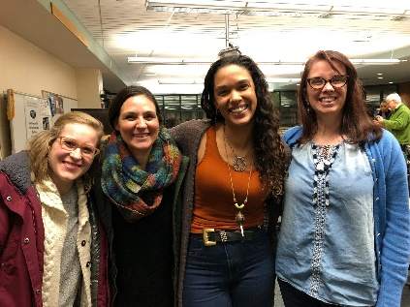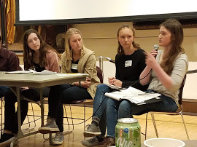

NEW RESOURCES for GreenStep Cities Best Practice # 24
Benchmarks and Community Engagement: Adopt outcome measures for GreenStep and other city sustainability efforts, and engage community members in ongoing education, dialogue, and campaigns.

Best Practice Advisor: Sean Gosiewski, Resilient Cities and Communities (RCC) 612 250-0389 sean@rccmn.co www.rccmn.co www.afors.org/resilientcities
- Schedule a conversation with me https://calendly.com/sean-g-rccmn to share your opportunities, challenges, brainstorm next steps and hear examples from similar cities.
Best Practice Actions
- Use a city commission, or committee to lead, coordinate, and report to and engage community members on implementation of sustainability best practices.
New: Environment & Sustainability Commission volunteers are now meeting up virtually by county for peer learning and support through the RCC network www.rccmn.co
New: The GreenStep Green Team Work Plan for 2020 covers tips for creating and maintaining successful green teams, case studies, testimonials, and step-by-step guidance
- Organize goals/outcome measures from all city plans and report to community members data that show progress toward meeting these goals (Comp Plans, Climate Action Plans)
Implement your new Comprehensive Plan Goals. Update land use, zoning and ordinances to meet new goals. Sustainability and Planning Commissions can help.
EXAMPLE – Bloomington’s Sustainability Commission meets annually with their City Council to approve their work plan to help meet priority goals.
- Measure and report progress on sustainability indicators including energy use/greenhouse gas emissions, social vitality/social inclusion outcome measures.
- NEW RESOURCE Met Council THRIVE INDICATOR DASHBOARD - Annual community-wide data soon to be available for Metro cities to track their progress on climate and social vitality! An interactive dashboard for continuous improvement, public accountability, and dialogue. Covers the five Thrive outcomes; Stewardship, Prosperity Equity, Livability and Sustainability
Contact: Mauricio León, Senior Researcher, Met Council, Regional Indicators 651 602-1146 mauricio.leon@metc.state.mn.us
https://metrocouncil.org/Planning/Projects/Thrive-2040/Thrive-Indicator-Dashboard.aspx
- Conduct or support a broad sustainability education and action campaign involving:
- Sustainability Commission volunteers share successful campaigns at their annual conferences and (New) through RCC County Cohorts of Cities www.rccmn.co
- Clean Energy Resource Teams – www.cleanenergyresourceteams.org
- Partners in Energy – with support from CEE, Xcel and Centerpoint staff - form a community steering committee, set energy efficiency and clean energy goals and engage residents and businesses to take action to meet them. NEW office hours/webinars to provide ongoing support to cities that completed PiE. www.xcelenergy.com/working_with_us/municipalities/partners_in_energy

- Conduct or support a community education, visioning and planning initiative using a sustainability framework such as: a. Strong Towns, resiliency, transition. b. Eco-municipalities, Smart Cities. c. Healthy communities, environmental justice, race equity.
- New! Climate Action Work Plans Can Provide Cities More Accessible, Near-Term Strategies Abby Finis, Planner, GPI (612) 767-7295 afinis@gpisd.net www.betterenergy.org
- NEW! Building Blocks for Regional Resilience in Southern MN Collaborative Resilience Planning with Cities and Counties in Region 9 with MPCA & EPA. Local leaders discussed the recent flooding and collaborated to strategize for future flood preparation and response https://brsinc.com/minnesota/
- New! BIPOC Mayors and City Council Members have formed a peer to peer learning and support network through Resilient Cities & Communities www.rccmn.co
- New! Broader equity and sustainability resources developed by the Sustainable States Network are a 13-page Equity & Sustainability Toolkit for cities. Equity in Action Database, a sortable spreadsheet with equity indicators & actions; list of 27 frameworks & tools; data web sites; sample equity plans. www.sustainablestates.net
- LMC Race/Equity resources coming soon for diversity, equity & inclusion training.

- Engage community youth and college students by creating opportunities to participate in city government.
- New! Student members of City Environment/Sustainability Commission will soon begin meeting virtually as a state-wide peer to peer learning and support network for youth from 30+ cities through Resilient Cities & Communities www.rccmn.co
- New! Climate Generation YEA! Campaigns (Local) with 5 MN Cities. An intensive mentorship program for youth ages 13–18 who want to win change for environmental justice in their city, town, county, or school district.
- New! Lead for America now available in MN. Fellowships for young leaders to work on the toughest challenges facing their communities www.lead4america.org

To find and use new resources for GreenStep BP #24 please contact Best Practice Advisor: Sean Gosiewski, Program Director, Resilient Cities and Communities, 612 250-0389 sean@rccmn.co www.rccmn.co www.afors.org/resilientcities

